AngularJS
Coursera
Sumario
Week 1 4
Installing the Atom text editor 4
Installing Git 4
Installing nodeJS 4
Installing browser sync 4
Creating a Github account and basic git commands 4
Lecture 4: AngularJS installation and first AngularJS app 5
Installing AngujarJS 5
Linking the view with the application 6
Creating the controller 7
Asociamos la controladora a la vista 7
Lecture 5: Sharing data with the view thorough Scope 8
Lecture 6: implementing NameCalculator example in AngularJS 9
Lecture 7: What is behind the magic. Custom HTML attributes 10
Lecture 8: Dependency injection 10
Lecture 9: How dependency injection works in Javascript? 10
Lecture 10: Protecting dependency injection from minification 11
Lecture 11, part 1: Expressions and interpolation 12
Lecture 11, part 2: expressions and interpolation 12
Week 2 14
Lecture 12: Filters 14
Lecture 13, part 1: creating custom filters 15
Lecture 13, part 2: creating custom filters 15
Lecture 14, part 3: creating custom filters 16
Lecture 14: digest cycle 16
Lectura 14, part: digest cycle 17
Lecture 14, part 3: digest cycle 17
Lecture 15: $digest and $apply 18
Alternative 1: call $scope.$digest() 19
Alternative 2: put the code inside the $apply service 19
Alternative 3: using the $timeout sevice 20
Summary: how to treat with no AngularJS events and launch the digst cycle 21
Lecture 16: 2-way, 1-way and 1-time binding 22
Lecture 17: ng-repeat 22
Lecture 18: filtered ng-repeat 24
Filtering an array while typing 25
Lecture 19, part 1: Prototypal inheritance 27
What is inheritance? 27
JS Prototypal inheritance 27
Lecture 19, part 2: prototype inhertitance 28
Function constructors 31
Lecture 19, part 3: scope inheritance 32
Controller as syntax 33
Lecture 19, part 4: Scope inheritance 35
$parent 39
Lecture 19, part 5: controller as syntax 39
Lecture 20, part 1: custom services 41
What for and what for not to use controllers 41
How to register a new service? 42
Services are created as singleton by AngularJS 42
Services are Lazy Instantiated 43
Lecture 20, part 2: custom services 43
The view with 2 controllers: the itemAdder and the showList controller 43
The app 43
The ShoppingListService 44
The itemAdderController 44
The showListController 45
All the code working 45
How to code for removeItem 46
Lecture 21, part 1: custom services with .factory() 48
Factory design pattern 48
Factory is not the same that singleton 48
Register service factory 49
How to obtain a service from the factoryFunction 49
Another way to obtain a service from the factoryFunction 49
The difference between the two approaches 50
Lecture 21, part 2: custom service with .factory() 51
Lecture 22, part 1: custom services with .provider() 55

Week 1

Installing the Atom text editor
www.atom.io
Descargamos fichero .deb
intentando instalar me dio un error, porque tenía dependencias con git
simplemente, ejecuto sudo apt install -f y se solucionó, ya tengo atom instalado

Installing Git
desde línea de comandos
git --version
y efectivamente me sale que tengo instalada la versión 2.7.4

Installing nodeJS
www.nodejs.org y en la sección de descargas lo descargamos
Simplemente descomprimimos el fichero .zip y añadimos al path del sistema la ruta hasta la carpeta bin
export PATH=$PATH:/home/moises/Descargas/node-v8.10.0-linux-x64/bin/
comprobamos que todo ha ido bien con
node --version
comprobamos tambień que npm ha ido bien con
npm --version

Installing browser sync
www.browsersync.io
y luego
sudo npm install -g browser-sync
al terminar, simplmente
browser-sync --version

Creating a Github account and basic git commands
Creamos la cuenta
Y marcamos para poder utilizar github para mostrar nuestras páginas
Clonar nuestro repositorio github en local
git clone https://github.com/moisespd/coursera-test.git
apm install atom-shell-commands
y luego, desde nuestra carpeta coursera-test, escribimos
atom .
y nos abre atom ya dentro de nuestra carpeta coursera
Creamos un fichero index.html y guardamos
git status
nos marca que hay un fichero nuevo que no ha sido añadido al repsotorio
git add .
añadimos todos los cambios al repositorio
git status
nos indica ahora que hay un fichero nuevo marcado para ser añadido al repositorio
git commit -m "comentario"
añadimos los ficheros que han sufrido cambios al repositorio
git push
y con esto hemos subido nuestros cambios locales a github
http://moisespd.github.io/coursera-test/
Visito mi página de github y ya vemo mi fichero index.html publicado

Lecture 4: AngularJS installation and first AngularJS app

Installing AngujarJS
Vamos a
angularjs.org
pulsamos sobre download, elegimos la versión a descargar, que sea la última de Angular 1, no Angular 2, yo he elegido Angular 1.6.9. Entramos y seleccionamos angular.min.js

Linking the view with the application
app.js
creamos una función IIFE, Inmediately Invoked Function Expression en la que declaramos un módulo Angular, al que llamaramos myFirstApp.
angular.module('myFirstApp', [});
El segundo parámetro es un array con las dependencias. En nuestro caso, array vacío porque no hay dependencias.
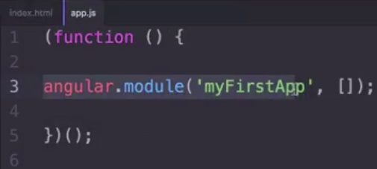
En index.html, marcamos ng-app="myFirstApp"
Tiene que ser exactamente el mismo nombre que le pusimos al módulo angular dentro del fichero app.js
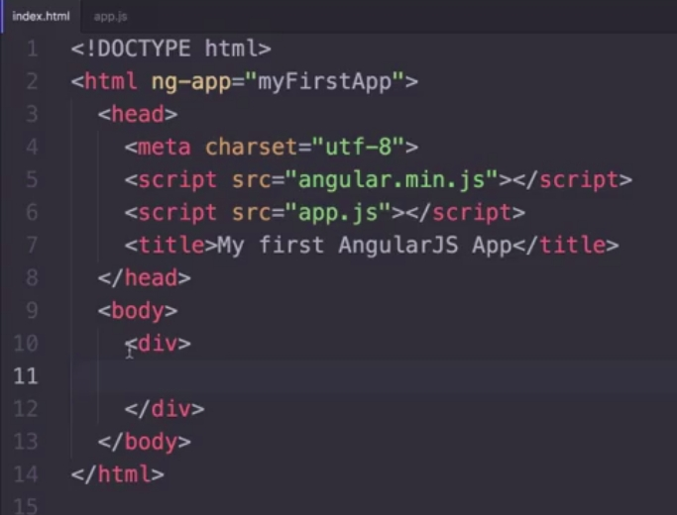

Creating the controller
Modificamos app.js para añadir la controladora:
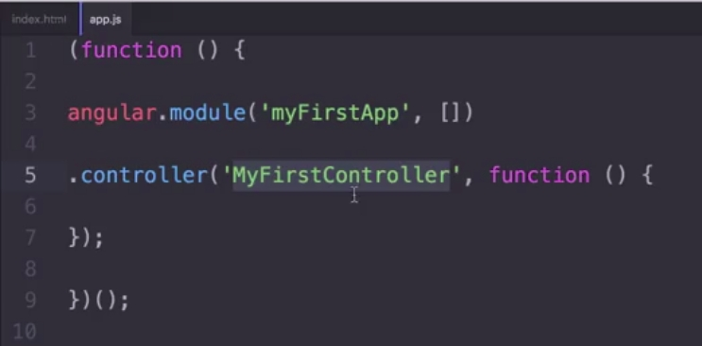
Como vemos, la controladora tiene una función que ahora mismo está vacía.

Asociamos la controladora a la vista
En index.html, asociamos a este div la controladora que acabamos de crear:

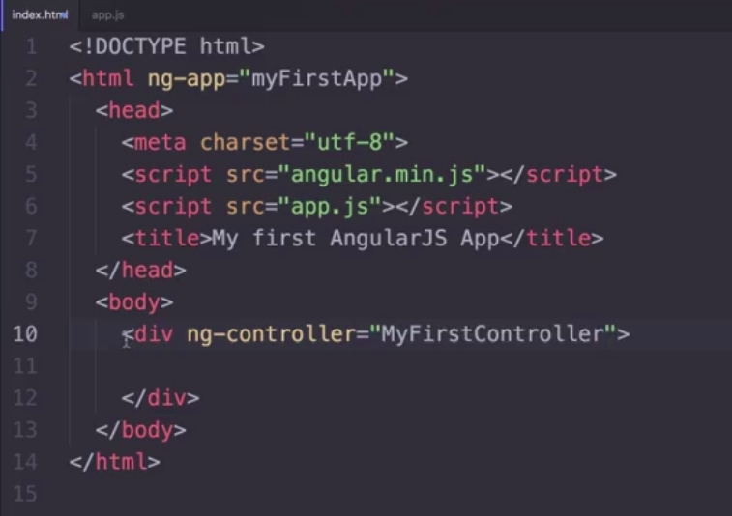
Digamos que index.html hace de vista y app.js hace de ViewModel

Lecture 5: Sharing data with the view thorough Scope
app.js
We create $scope as a parameter on the controller function.
Now, we can add properties or functions to our $scope parameter. The $scope variable will be visible from our view
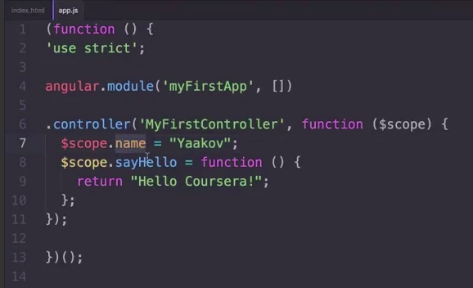
use strict is used to ask the javascript compiler to be strict

index.html
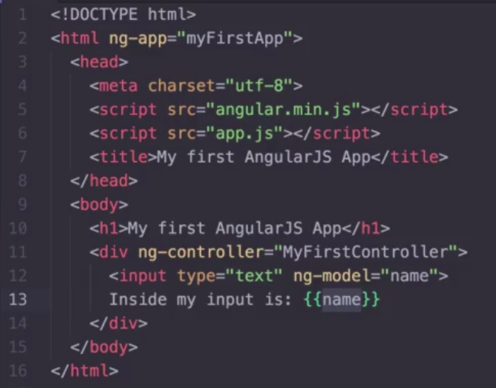
Now, in index.html we can access the $scope varible we declared in the controller by simply invoking its methos or its attributes inside a double courly braces:
with attribute ng-model we can bind it in an input text object.

Lecture 6: implementing NameCalculator example in AngularJS
app.js
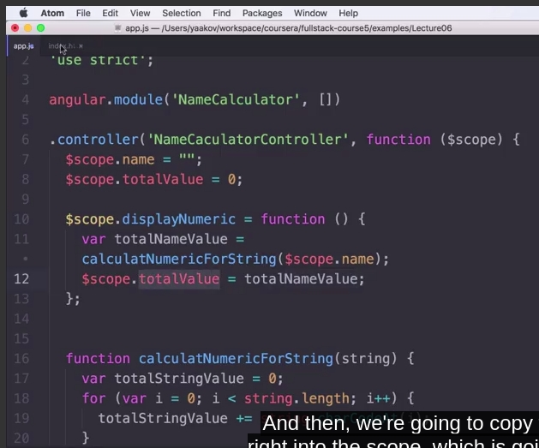
index.html
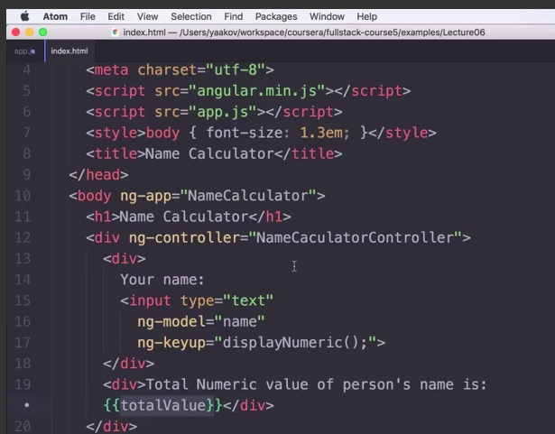

Lecture 7: What is behind the magic. Custom HTML attributes
In this video it is explaind document.querySelector("[attribute_name]") to look for the element which contains the attribute.
So ng-app and ng-controller are simply attributes ignored by the navigator but which are used by the angular.js framework.

Lecture 8: Dependency injection
It is explained the pattern Inversion of Control
I did not understand it very well. ###

Lecture 9: How dependency injection works in Javascript?
In angular, everything with a $ in the beginning of the name, is a service
So $scope, it is indeed a service
$filter is a service that lets us filter or format the data that will be presented to the user
We can retrieve a function, but not its value, its code:
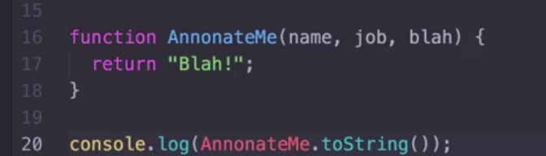
As you see in the figure, AnnotateMe is a function, and we are writing to the console the full code of this function:
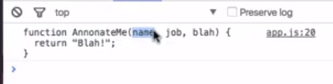
So, the service $injector is a parser, wich receives the name of a function and it is able to parse the code. That is how Angular works.

Lecture 10: Protecting dependency injection from minification
This video it is explained how our code in Angular will not work if we minimize our code, because Angular framework will look form special names, such us $scope and $filter, and, because we minimized the code, this names are not presente in the minimized version of our code.
https://javascript-minifier.com/
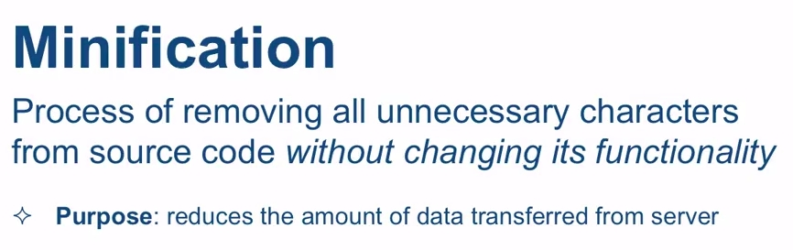
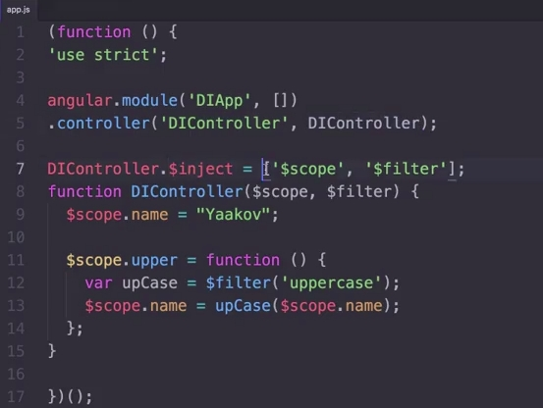
In this figure we show how to avoid minification problem.

Lecture 11, part 1: Expressions and interpolation
This is an expression:
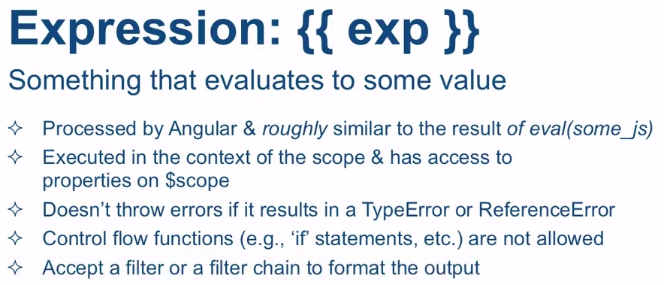
and this is interpolation:
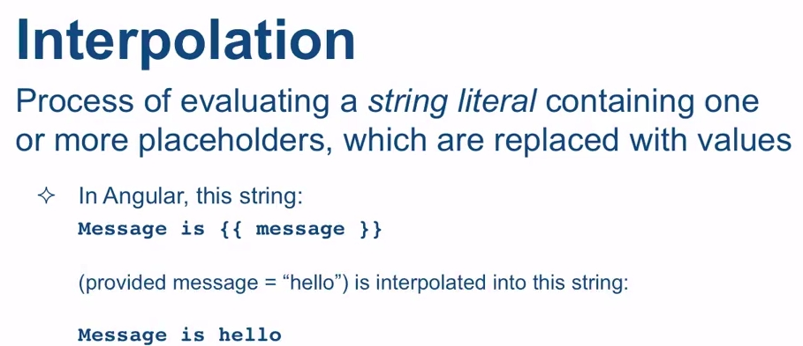
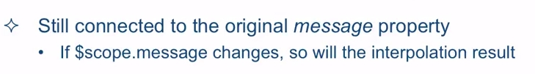

Lecture 11, part 2: expressions and interpolation
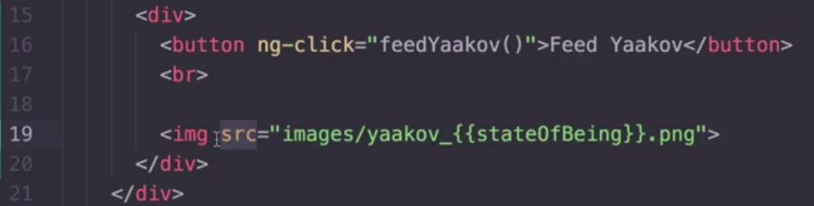
We can use expressions to compose the name of an image. However, it will produce an error, because when the parser gets to this line, it still has not being processed by Angular, so it will produce an error, althought it perfectly works.
The way to solve this is using the ng-src attribute for images, so it will be processed when Angular is ready.

Week 2

Lecture 12: Filters
Using the uppercase filter:
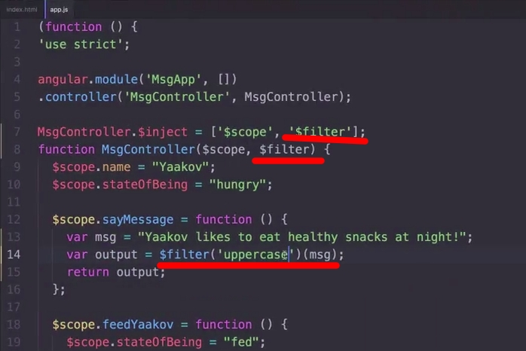
Using filters from the html page:
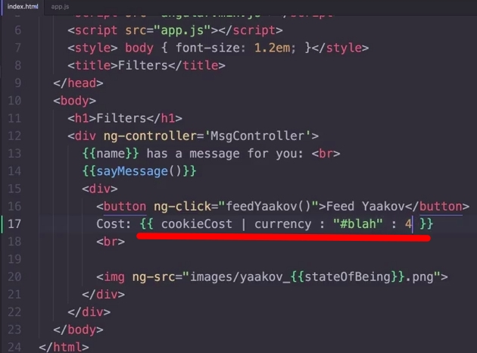
cookieCost: The first argument is the value to be formatted
currency: the type of the filter to be applied. This is a currency filter
symbol: This is the symbol of the currency. By default it is $, but it could be "€" or in this example, "#blah!"
decimal digitgs: this is the number of decimal digits you want. In this example, 4 digits

Lecture 13, part 1: creating custom filters

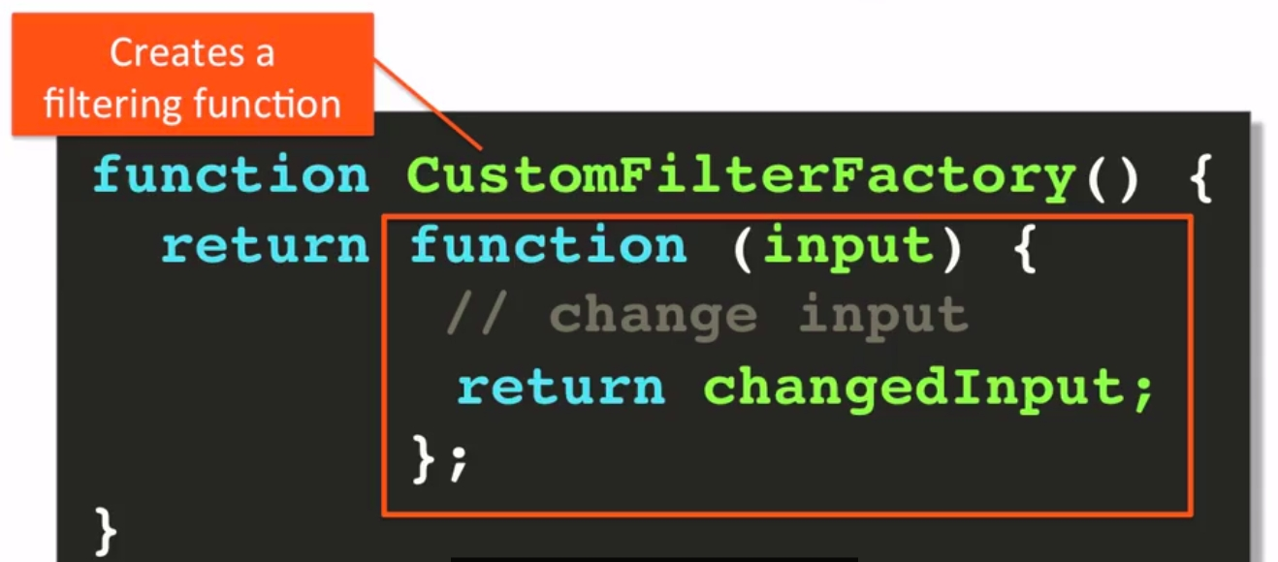 | 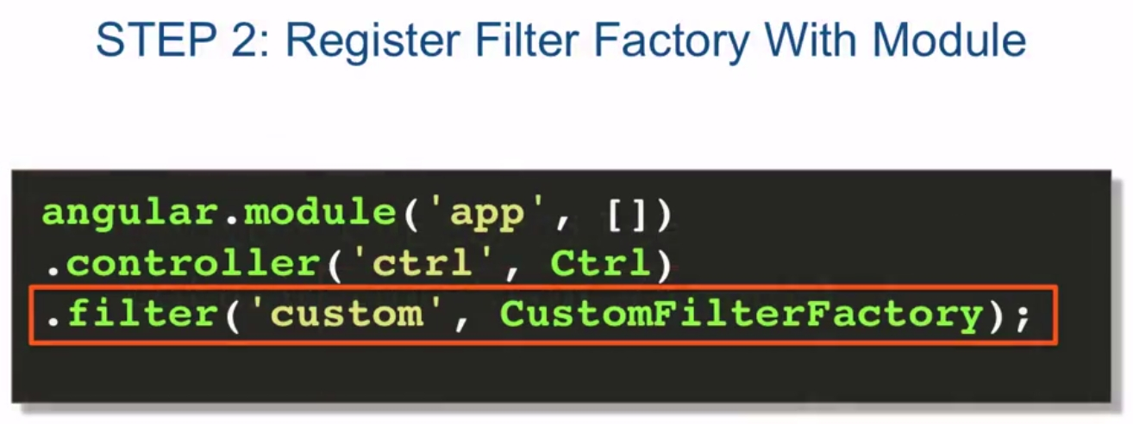 | 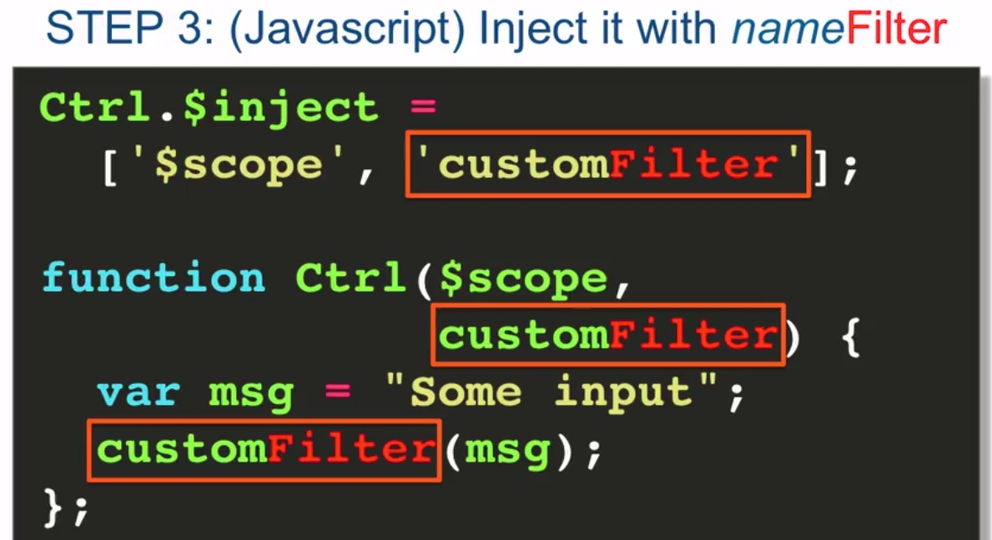
Step 1: define filter factory function | Step 2: register filter factory with module | Step 3: inject it with nameFilter

Lecture 13, part 2: creating custom filters
Example of creating a lovesFilter
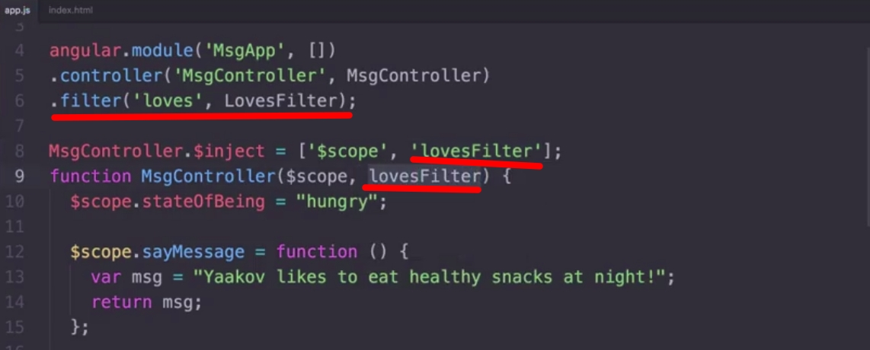 | 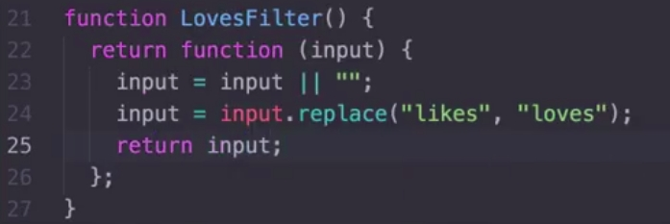
Step 1  Add .filter to the controller  inject the lovesFilter  in the controller we add the lovesFilter param | Step 2  Define the LovesFilter function
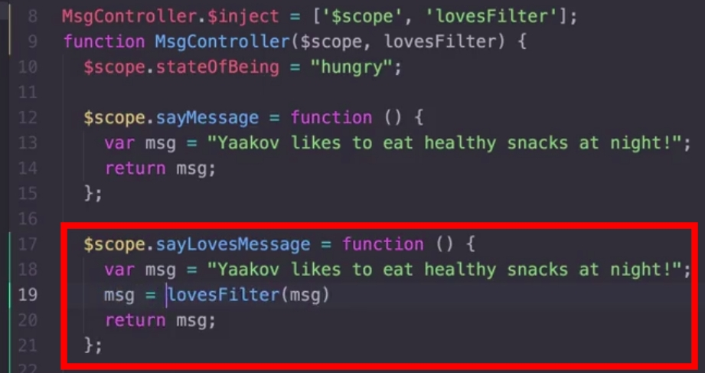 | 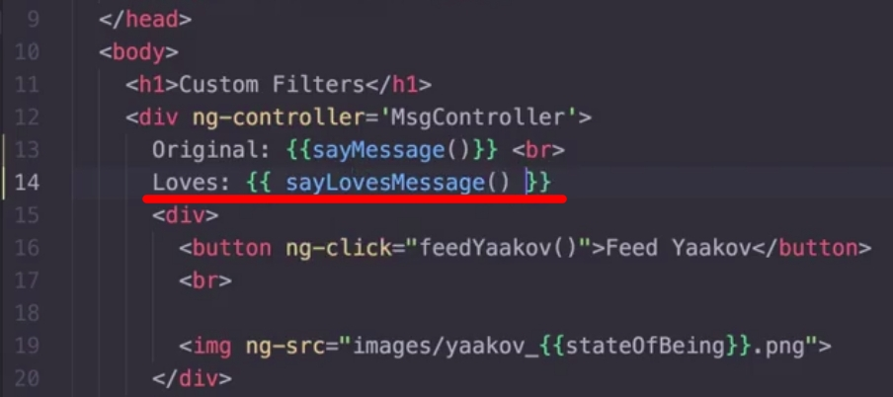
Step 3  call the lovesFilter function from the sayLovesMessage in the scope, so it will be visible outside the controller | Step 4  Call the new function from the html

Lecture 14, part 3: creating custom filters
We will create now a filter which receives aditional arguments
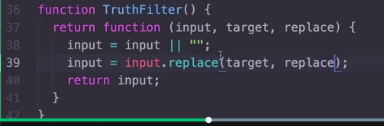 | 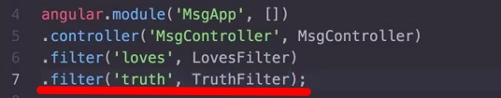
Step 1  We create a new filter, wich is called TruthFilter | Step 2  Register the filter in the controller
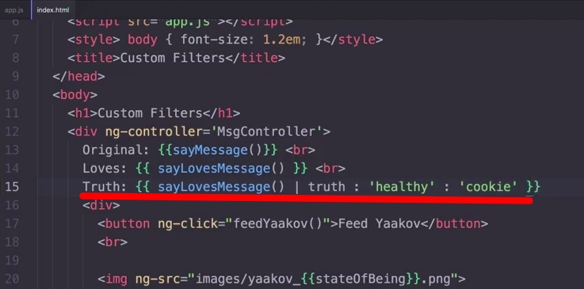 | 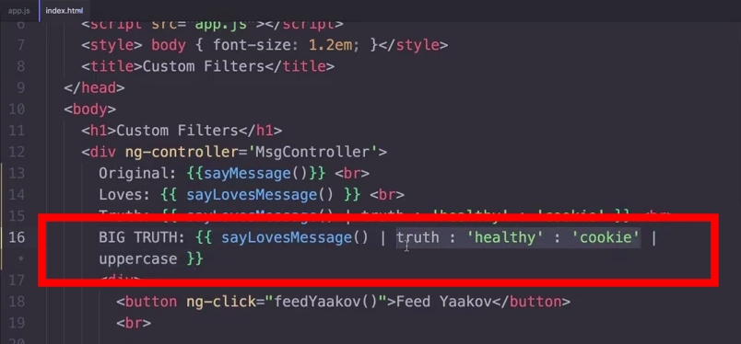
Step 3  Use the new filter from the html page | step 4  concatenating filters

Lecture 14: digest cycle
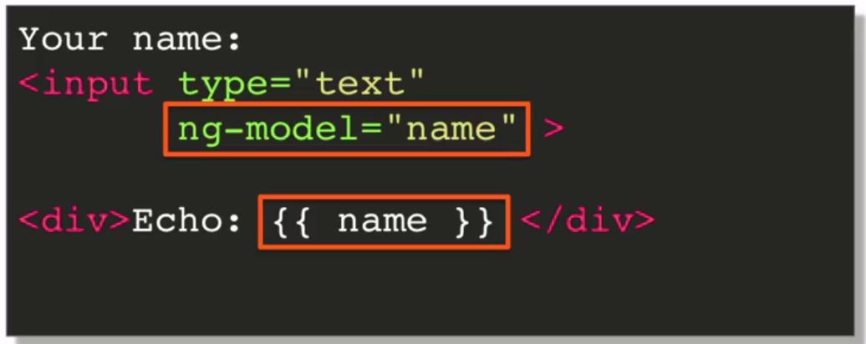
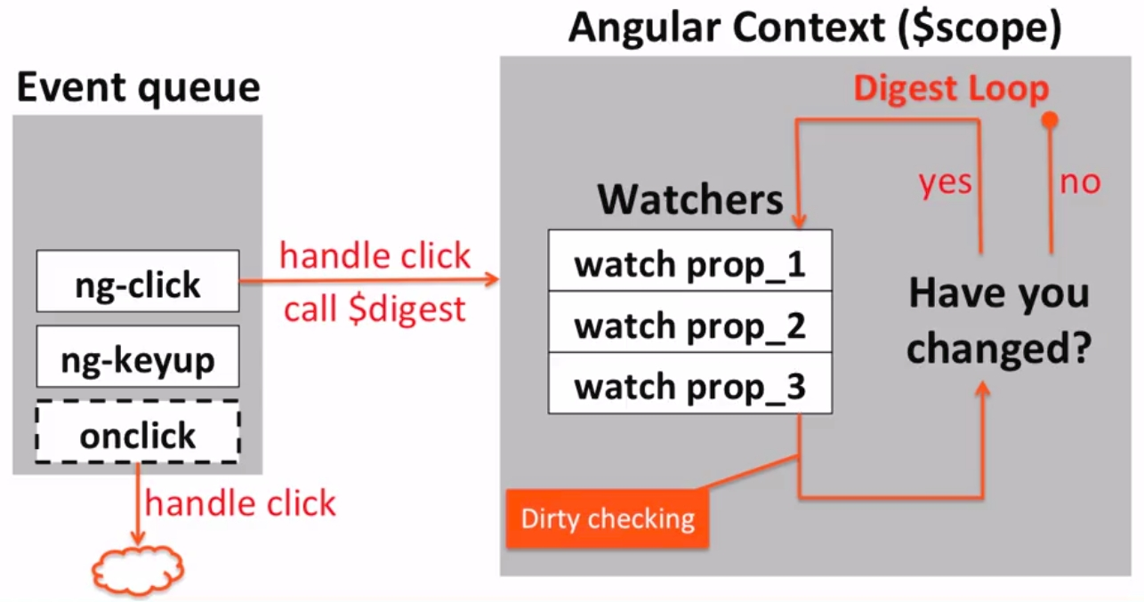
When one of the angular events is declared, what Angular does is the Digest Cycle, which means that it asks all the watchers of all the properties to see if any of them have changed. If so, it updates whatever on the html, and then, asks again if any has changed. Angular repeats the loop until no property has changed.

Lectura 14, part: digest cycle
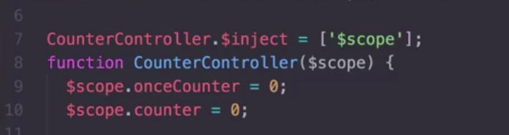 | 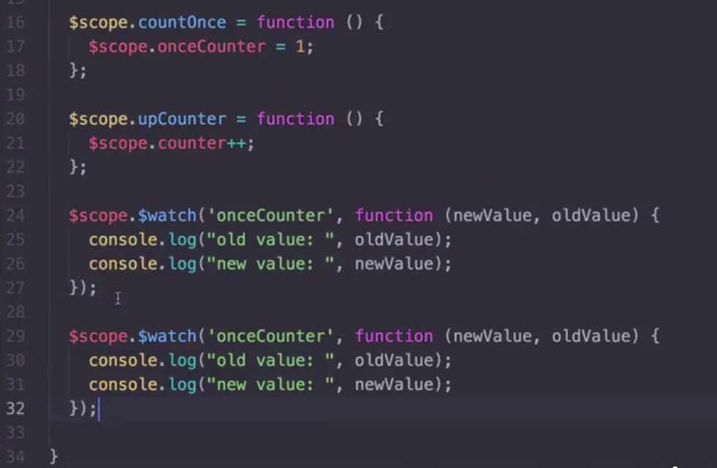
Declaring to variables in Angular we will watch | Defining two methods to modify the values of our two properties  Also registering a watcher for each of the properties using $scope.$watch function inside of the controller  we can access the new value and the old value
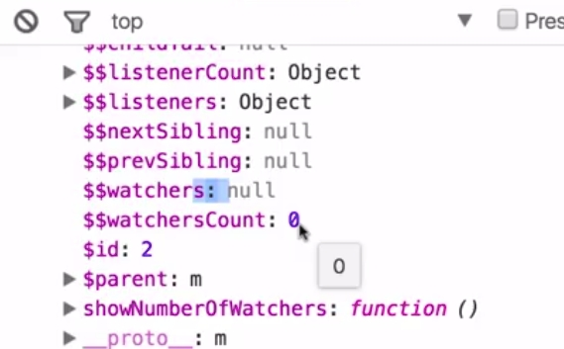
console.log($scope)
You can see $$watchersCount or $$watchers
At the initial moment there is no watcher defined

Lecture 14, part 3: digest cycle
Using $scope.$watch function is not recommended!
By simply doing {{ property_name }} in the html file AngularJS will create a watcher for that property
Then, he do shows how the digest cycles is fired twice when we modify any property
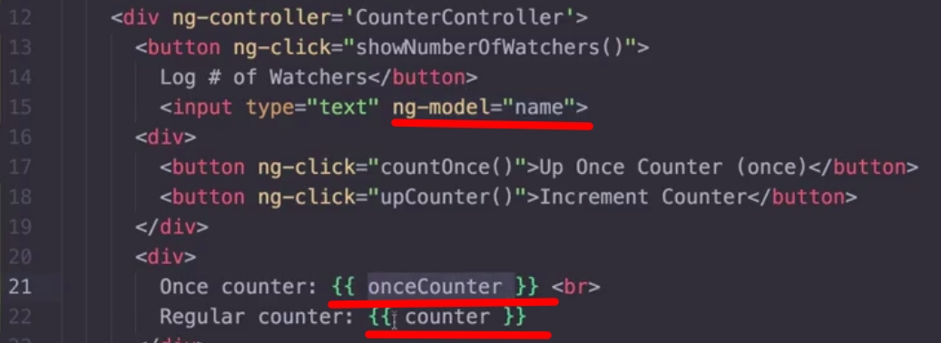
Three different ways to create a watcher automatically from AngularJS instead of using $watch internal function

Lecture 15: $digest and $apply
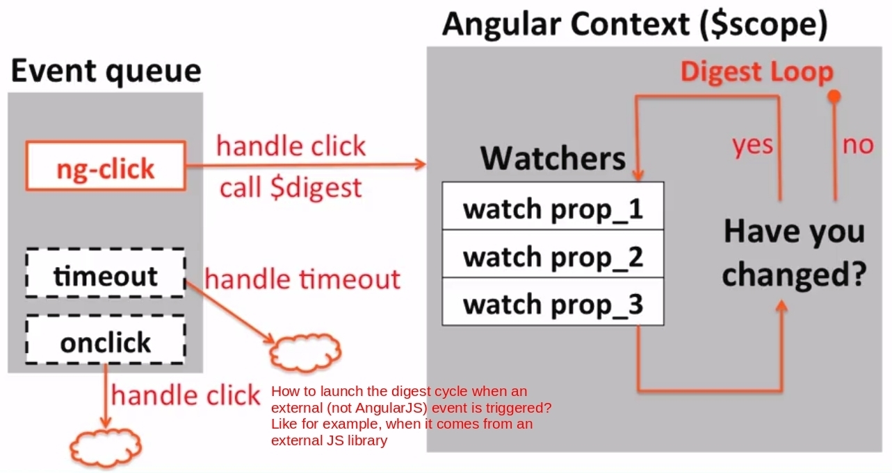
This lecture is about those events which are not in AngularJS context, but which affects our properties, so it would be necessary that the digest cycle would occur. Like for example, when a onclick event if triggered, for example from another library we are using in our application. How to deal with it?

Alternative 1: call $scope.$digest()
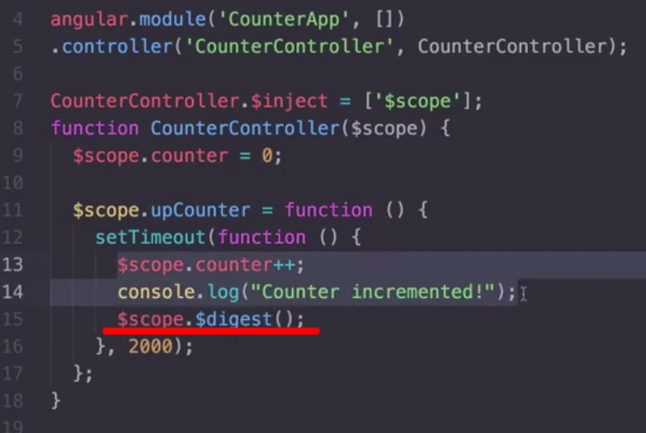
We have changed our counter application so the counter will be increased two seconds after the button is clicked:
if we do not add the 14th line, $scope.$digest(), the value will not be updated in our html view because the digest cycle will not be fired, because the setTimeout function is out of the AngularJS context, it is not visible to AngularJS.

Alternative 2: put the code inside the $apply service
The best way to do this is inside the $apply service, so if there is any interruption, any exception during the execution, AngularJS will treat it:

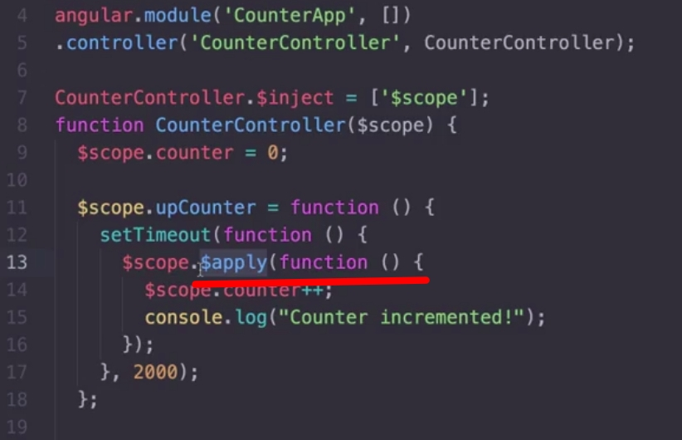
All in $apply is under the AngularJS context so it will launch the digest cycle.

Alternative 3: using the $timeout sevice
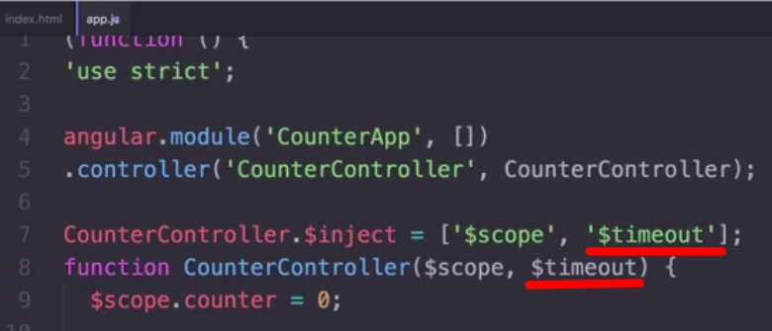
First of all, inject the $timeout service in our controller

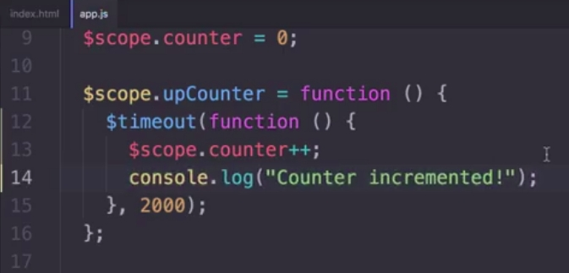
And now we can define the $timeout function

Summary: how to treat with no AngularJS events and launch the digst cycle
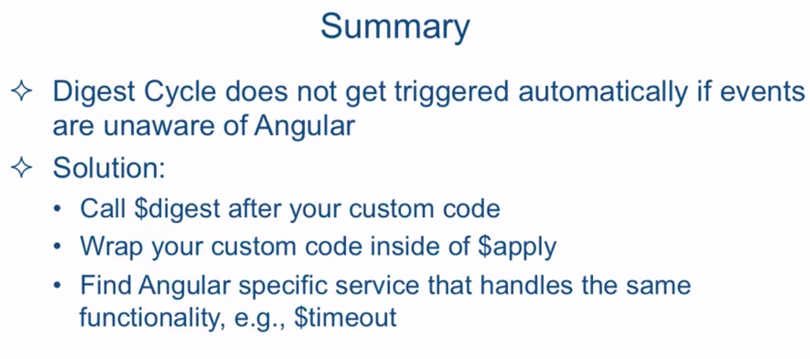

Lecture 16: 2-way, 1-way and 1-time binding
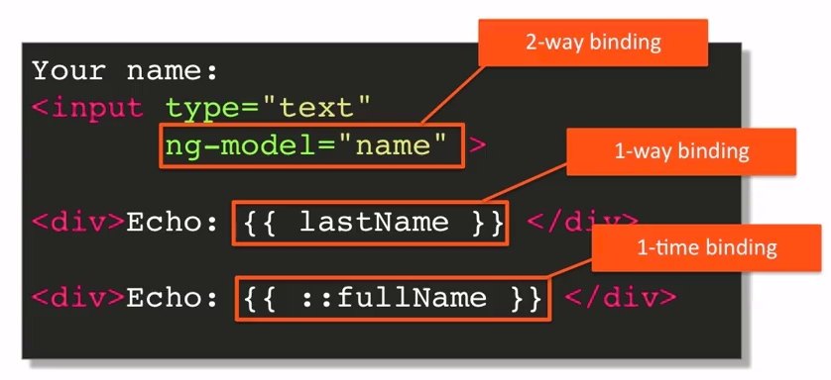
Think that every watcher in our page consumes CPU time, so, a page can work in a fluid way with more or less 2000 watchers. The result is, less watchers, faster the page works.
The last one, {{::fullname}} means that, after the property is displayed in the html, the watcher associated can be removed, because it won't be changed in the future.

Lecture 17: ng-repeat
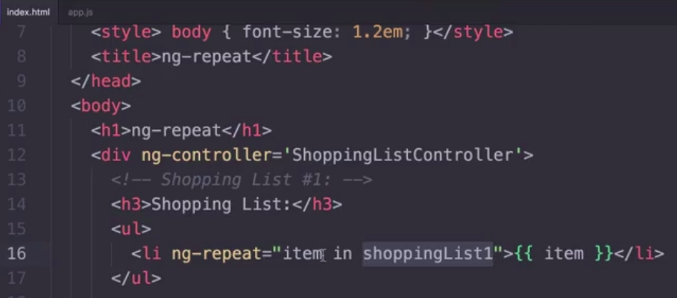
This is the directive to do a repeat in AngularJS

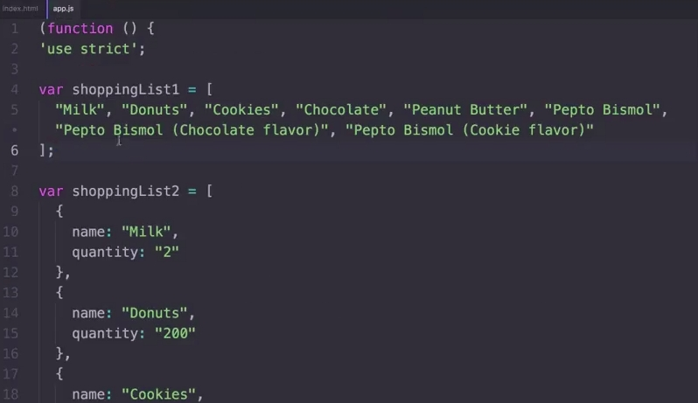
This is the ShoppingListController, and its shoppingList1 and shoppingList2
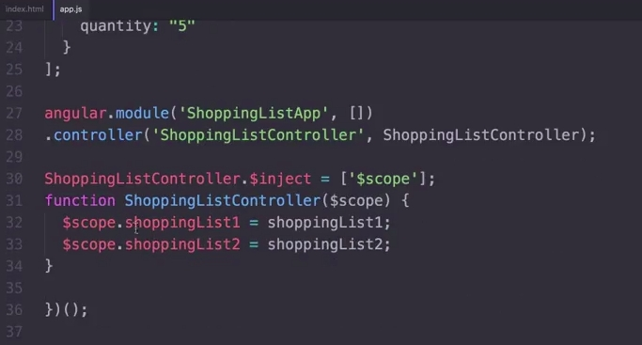
As you see, both lists are declared before the angular.module
We add both properties the shoppingList1 and shoppingList2 to the $scope service.
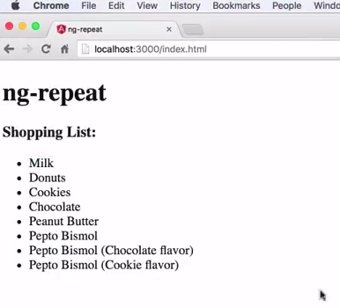
This is what we get in our index.html

In the next example we do a ng-repeat with the list2:
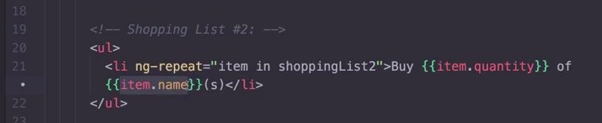
Remember that list2 is an array of objects, with the name and the quantity of each item.

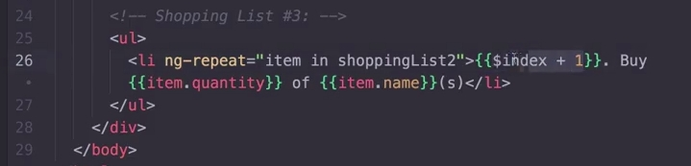
With $index we can get access to the index of the ng-repeat iterator.

Lecture 18: filtered ng-repeat
Example of how to use filter method in arrays:
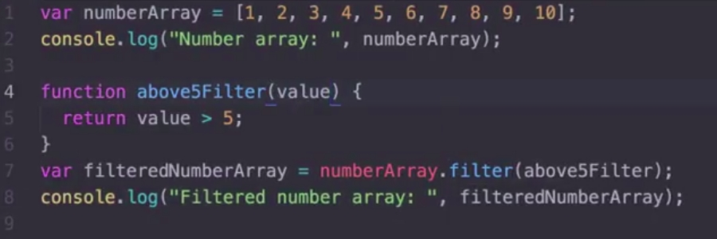

The same way we can use filter with arrays of strings. For example, in our shopping list, we can filter all the elements that contains the word "Bismol":
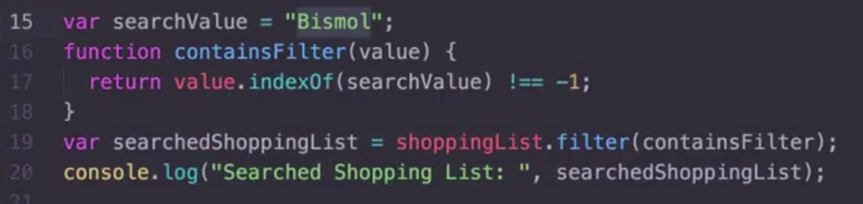

Filtering an array while typing
Now that we know how to filter arrays, and we also know how to do an ng-repeat to draw the shopping list, what if we add a text box, so while we type something, the ng-repeat that represents the list, at the same time it is filtering its contents:
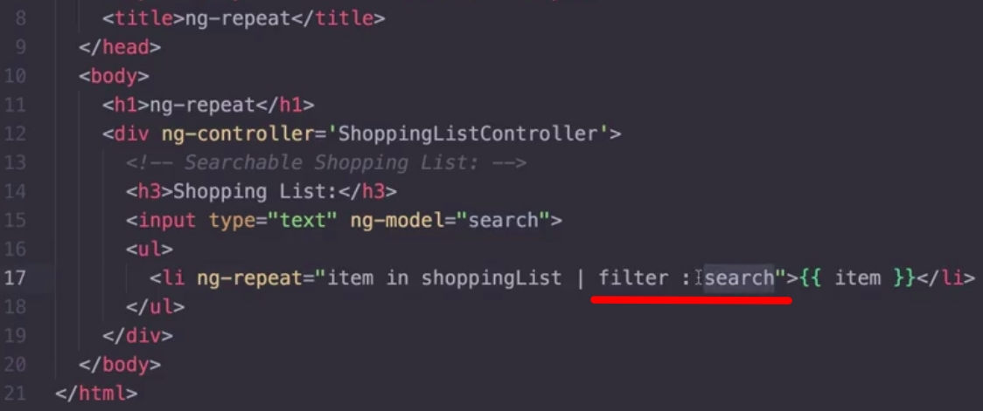

Now, while we start writing "Bismol", our shopping list will be filtered automatically on the fly:
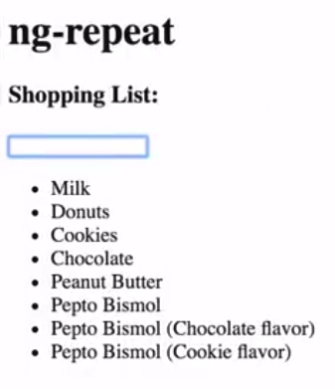 | 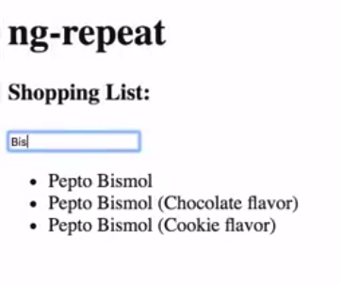

Lecture 19, part 1: Prototypal inheritance

What is inheritance?
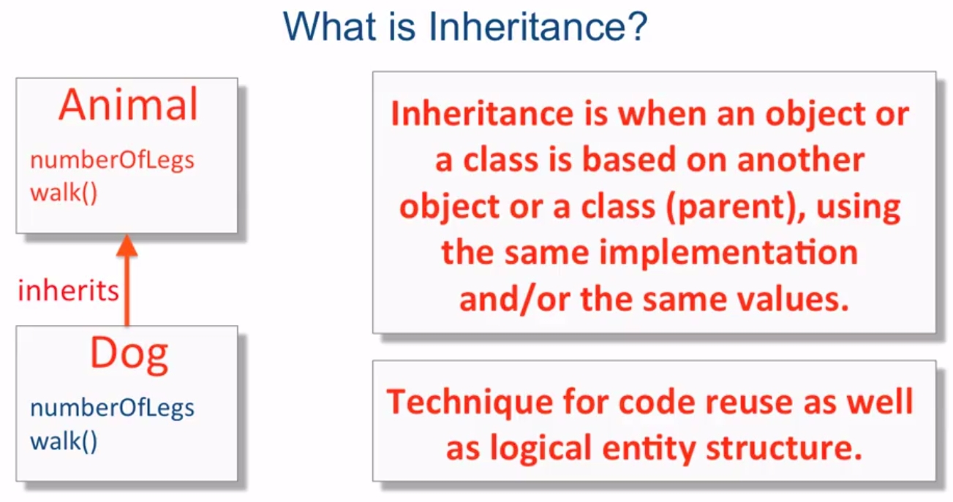

JS Prototypal inheritance
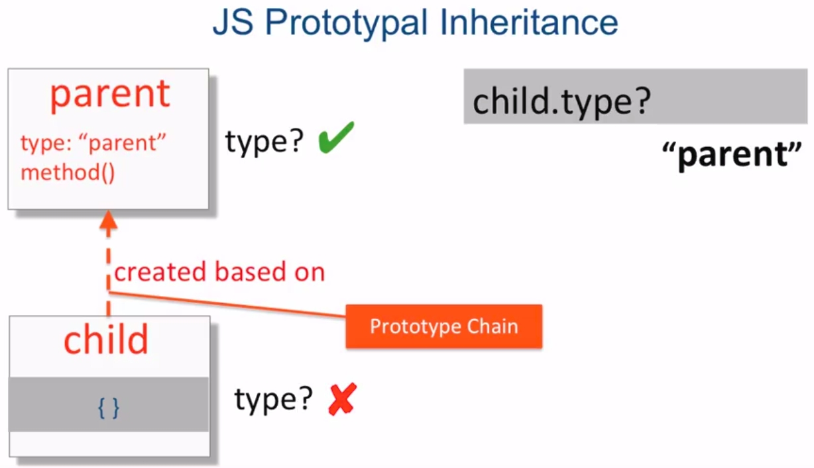
The child object is initially created as empty. If we ask for child.type, JS will look for this property first in the child. Because there is no property called type in the child, JS will continue looking for this property in its parent, in what it is called the property chain. JS will find this property and will return the value of "parent", which is the value of the property type in its parent.

What shall happen if we set a property type in the child? child.type = "child"
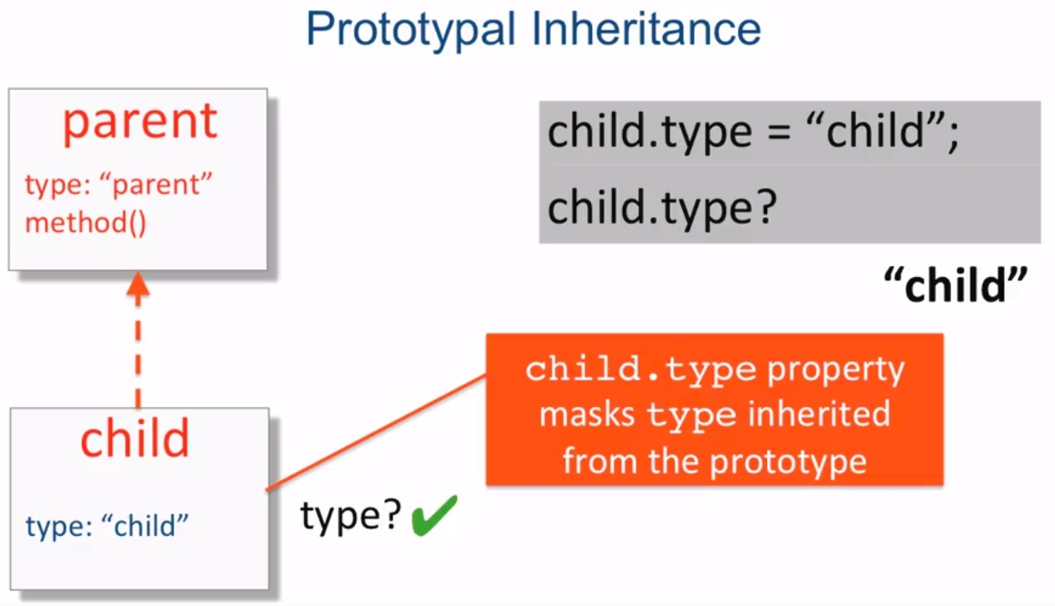
if we ask for child.type, JS will look for this property in the child object, and because it is defined, JS will not continue UP looking for its value and returns "child". We have masked the property type of its parent.

Lecture 19, part 2: prototype inhertitance
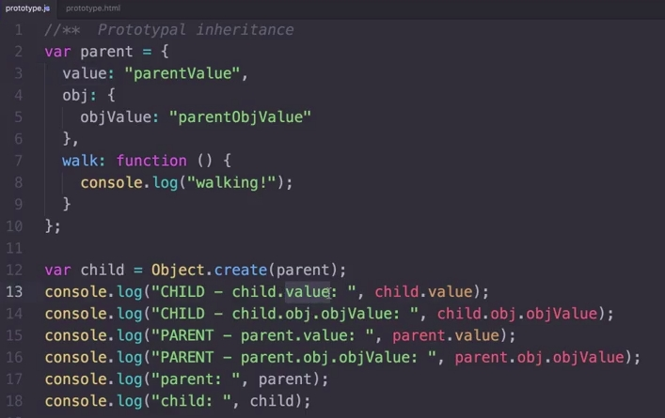
Here you can see how to create an object, with its properties and its methods and how to create a new object using prototype inheritance with Object.create().
And this is the output that what we get:
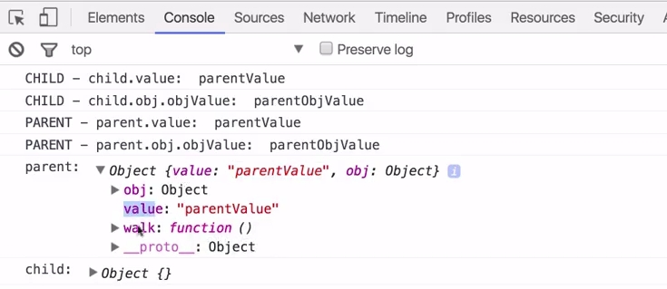

What about if we modify our child object? Look at the next piece of code:
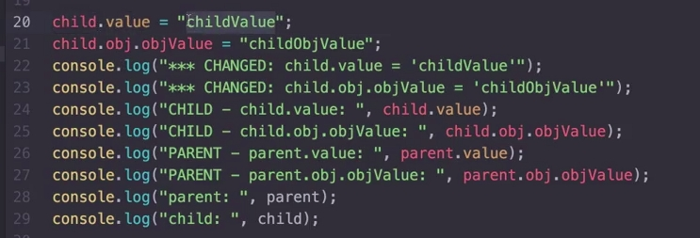

This is what we get in the output:
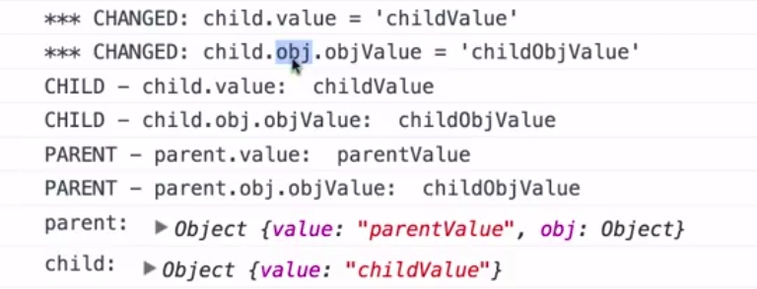
As you see, the child.value will mask the parent.value property.
However, the object property, which is a reference to an object, which is only in the parent, will be overwritten when we modofy it in the child. Now, when we set the child.obj.objValue we are modifying the parent object, there is not a copy for the child.
As you see in the parent and the child objects, there is not a property obj for the child.

To confirm what we think, lets aks to the JS engine if child.obj === parent.obj
And this is what we get:
Lets now create a grandchild:
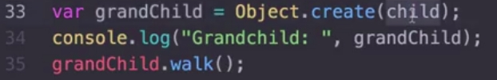
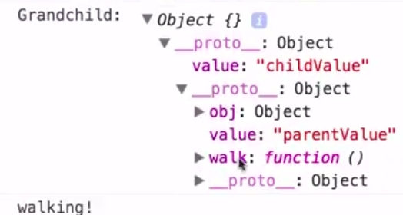
As you can see, the grandchild is an empty object, which has a reference to the child object, which has a reference to the parent object.

Function constructors
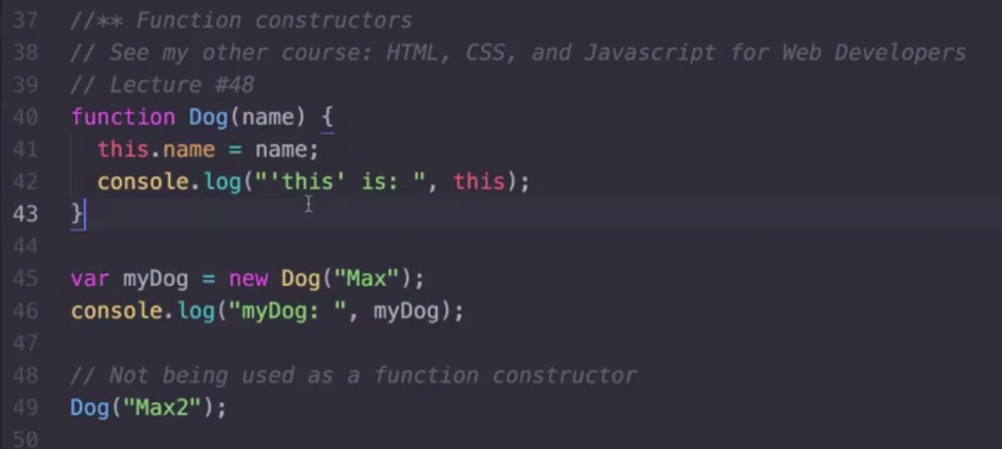
This is a way to use functions to create classes.
We can use the reserved word this to access the object and we can create objects of this class by using var myDog = new Dog("Max");

Be careful, because if you do not use the keywork new before Dog, it is, before our function, you are simply calling the function Dog, so, the keyword this will be the global scope which is, in a navigator, the Window Object.
Tip: When the function starts with capital letters, it is not a regular function but a class function

Lecture 19, part 3: scope inheritance
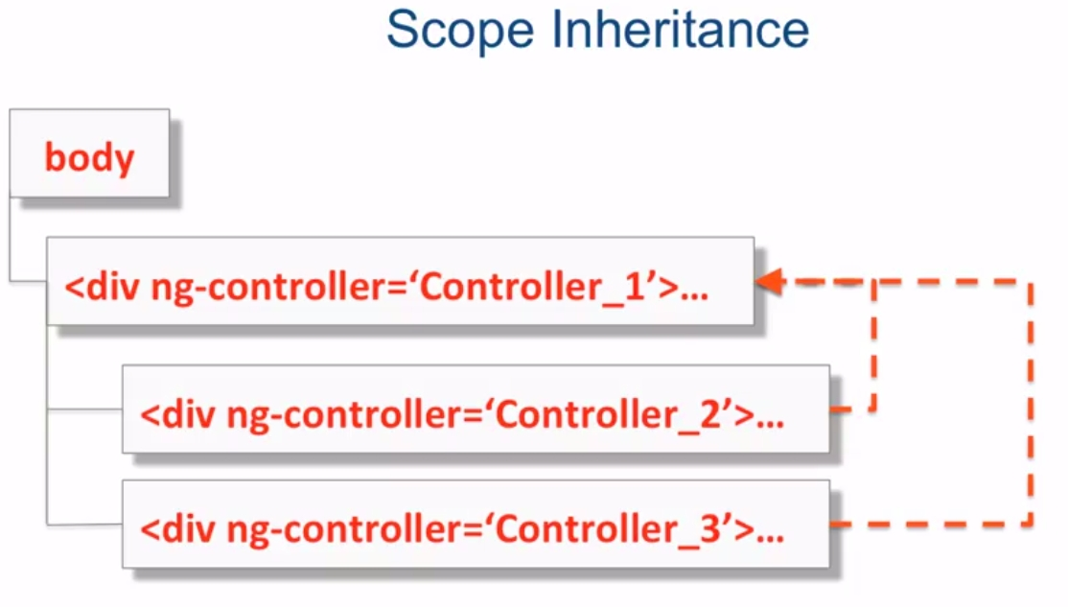
Instead of having only one controller which controls absolutelly everything in our page, it is better to have smaller controllers which controls different parts of our page.
AngularJS will let us do it very easyly, by using prototype inheritance, to divide the controlling in several controllers by not masking the parent controller.

If we declare a property in the first controller, lets say $scope1.prop, which value is "ctrl-1", we can access this property from the inner controllers.
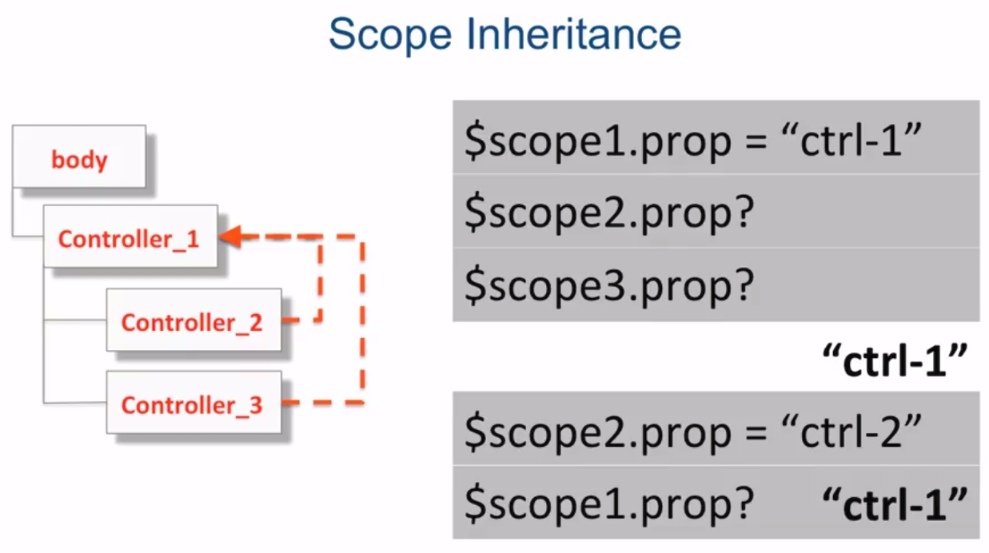
However, if we do want to change this property value from controller2, by doing $scope2.prop = "ctrl-2", this will only affect the controller 2, and it will keep its original value in controller1: remember the prototype inheritance, the child object will create a new property for itself. So, when controller1 or controller3 ask for the property prop, they will get the value "ctrl-1", not "ctrl-2".
How can we solve this? How can we have a property in the master controller that can be treated as a global value, it is, if we change its value in the master controller or in any inner one, the change will be effective for all of them? To do this, we will declare the properties inside an object property. This way, all the controllers points to the same memory location.

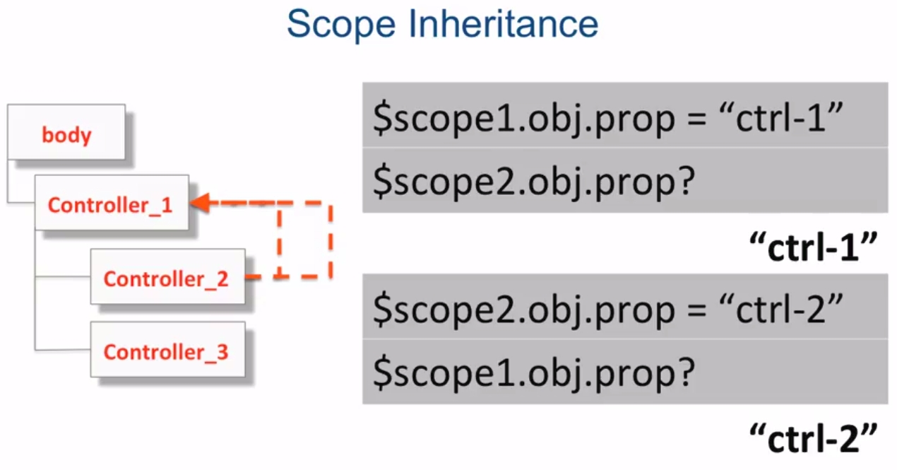
Controller as syntax
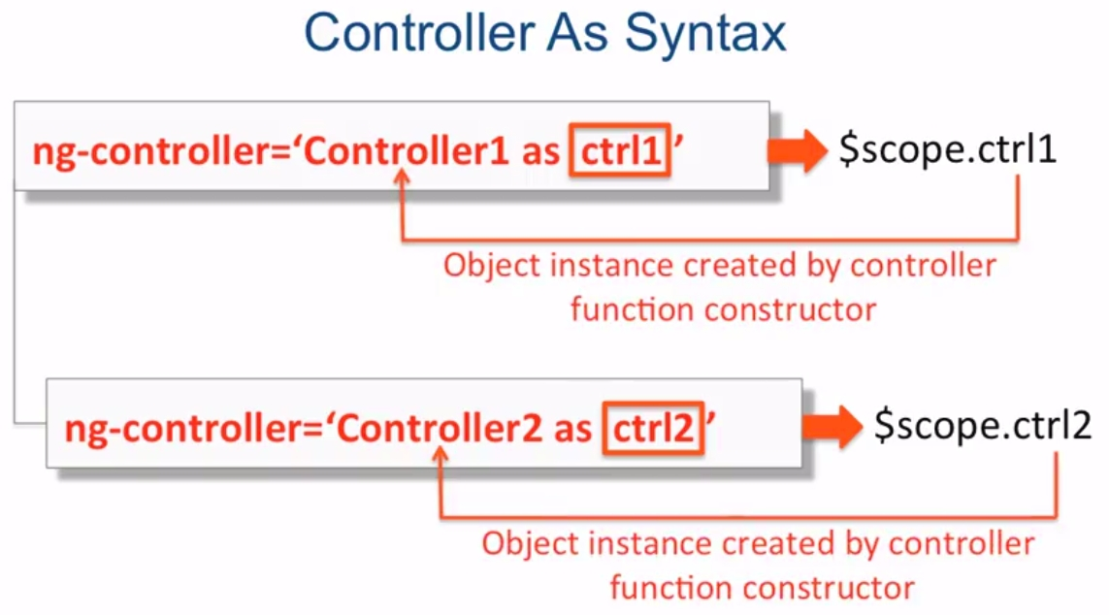
Doing this, we can use the keyword this instead of $scope to reference the controller properties:
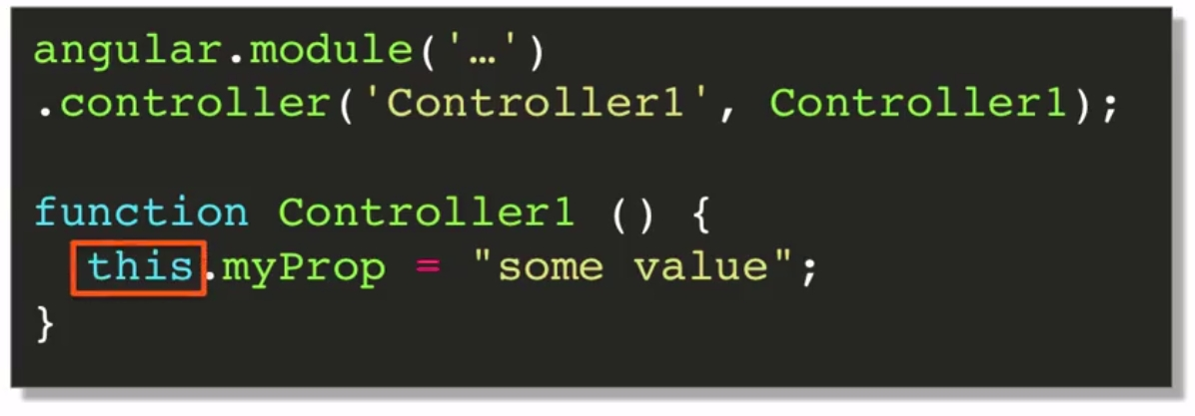
but, what is happening behind the scenes?
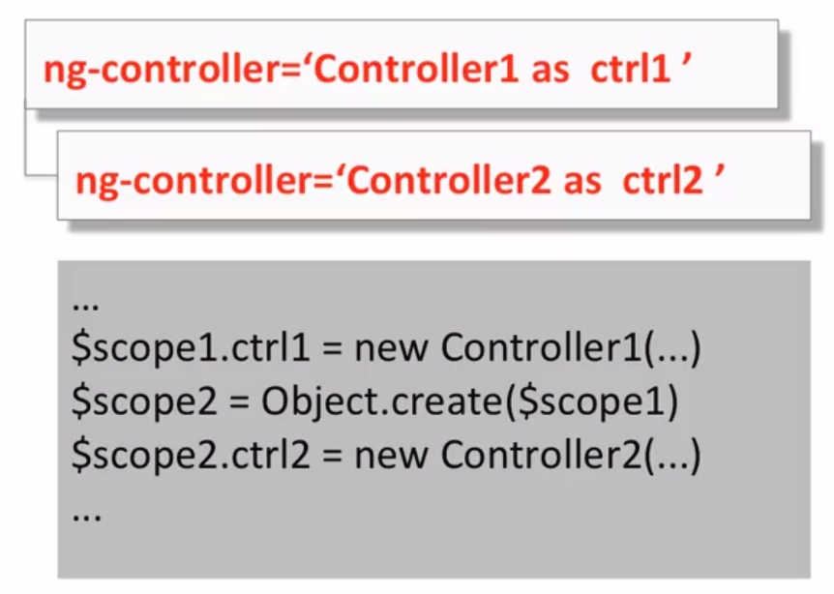
As you can see bellow, $scope1 and $scope2 are creating a new object which is called ctrl1 and ctrl2, the same way we defined in the as clausule, so it points to the same memory location.

How do we access this properties in HTML?
The code is much more clear, we do {{ ctrl2.myProp }} and {{ ctrl1.myProp }}
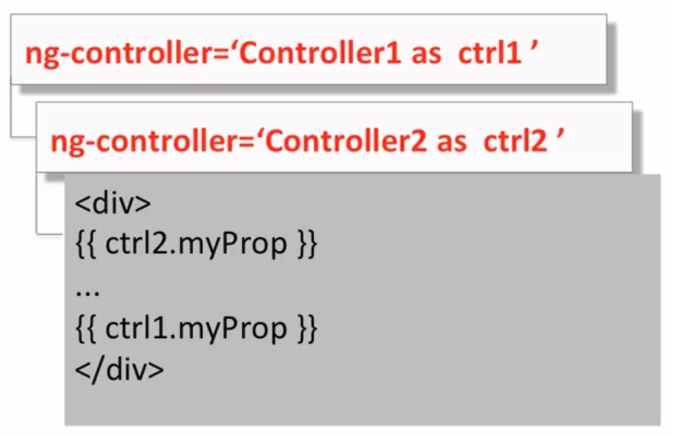

Lecture 19, part 4: Scope inheritance
Let us see all this theory in practice. This is our html code, in which we do have two nested controllers, ParentController1 and ChildController1:

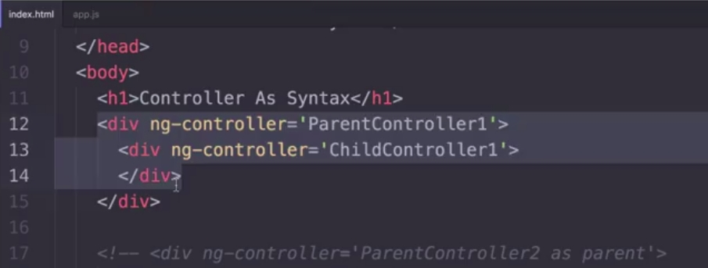
This is the code of the app.js:
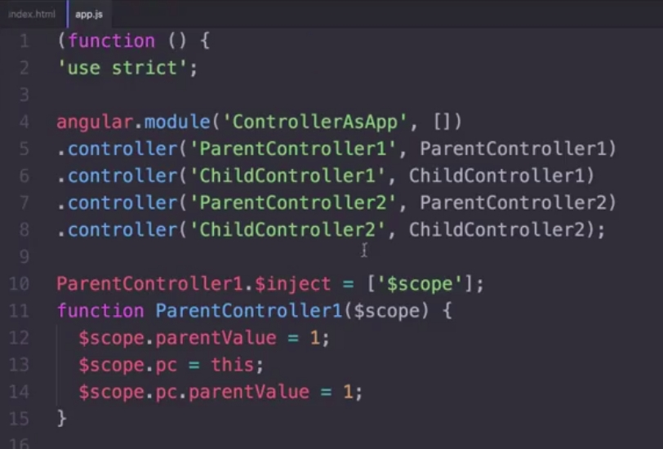
And here it is the code for the ParentController1 and for the ChildController1 inside the app.js:
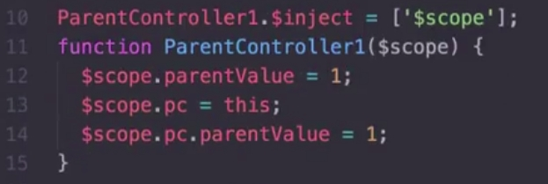 | 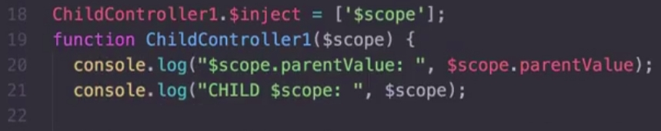
ParentController1 | ChildController1

When we do console.log($scope.parentValue) from the child, remember that the child controller did not have any parentValue property. It will ve retrieved from the ParentController. In the next figure you will see how it returns 1, which is exactly the value of the parent controller:
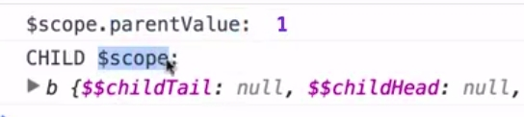
Now, if we do take a look at the $scope of the child controller, it does not have any ParentValue property:
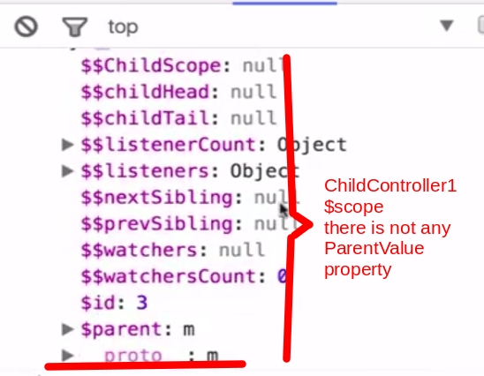
However, if we do take a look at the __proto__ property, we will see this is the ParentController1 object:
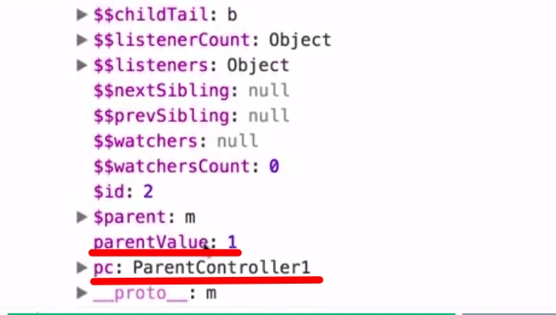

Knowing this, let as see some more code snippets:
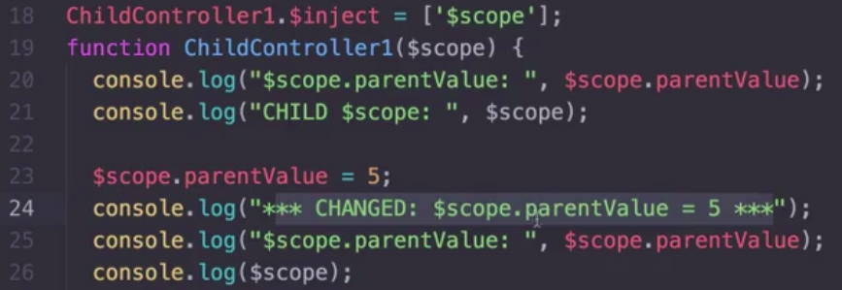
What we have done is setting the property parentValue in the ChildController. What will it happen? It will mask the ParentValue property of the ParentController1, so both controllers will have its own property, because it is a primitive property, a string property.

Now, lets examine the last chunk of code:
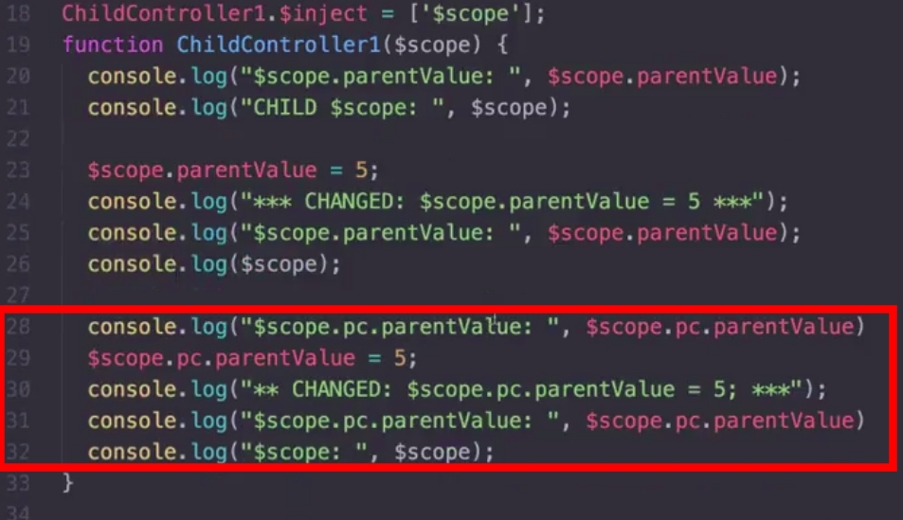
We are now accesing the object property pc in the child controller. Remember this one points to the same memory address than the ParentController, so, any change in it, will cause the ParentController also changes.

$parent
AngularJS exposes a property which is called $parent which points to the parent object. So, in our example, we can access $scope.$parent.parentValue, which is the value of the ParentController1 property:

Lecture 19, part 5: controller as syntax
Now, we will use the as syntax for the controllers. This is the code for the index.html:
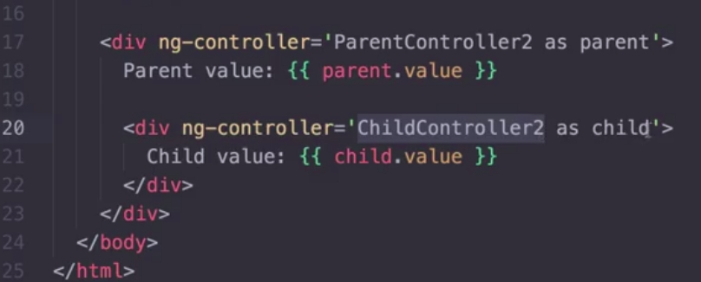
And this is the app.js code:
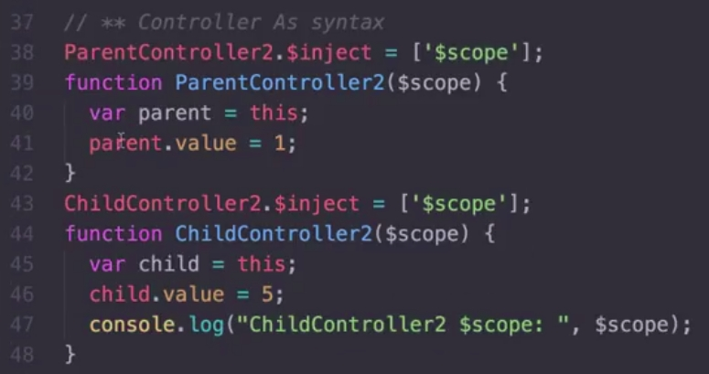
REMOVING THE $SCOPE
Working this way, it is not necessary to use $scope, so we could remove the lines 38 and 43, we do not need to inject the $scope service. Alse, we could declare the controllers without the $scope parameter.

Lecture 20, part 1: custom services

What for and what for not to use controllers
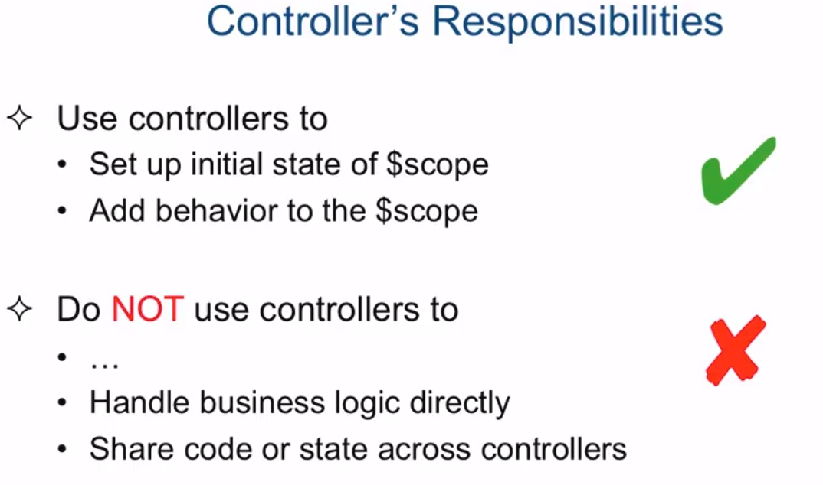
When we say use controllers to add behaviour to the $scope it means to manage the events in the IU so the $scope properties will be updated according to those events.
Do not use controllers to handle business logic directly and do not use controllers to share code or state across other controllers. This will be done via custom services.

How to register a new service?
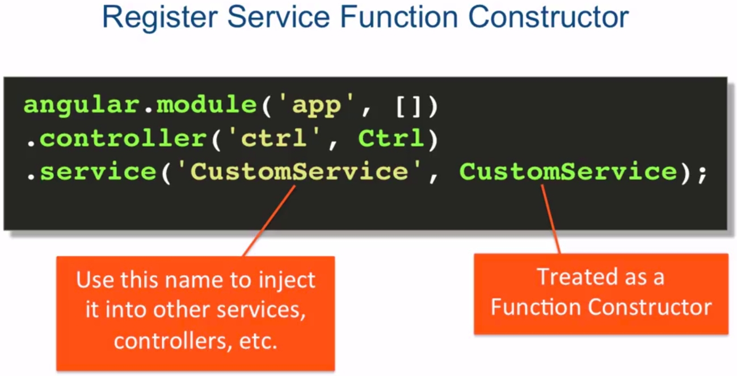
The service will be treated as a singleton

Services are created as singleton by AngularJS
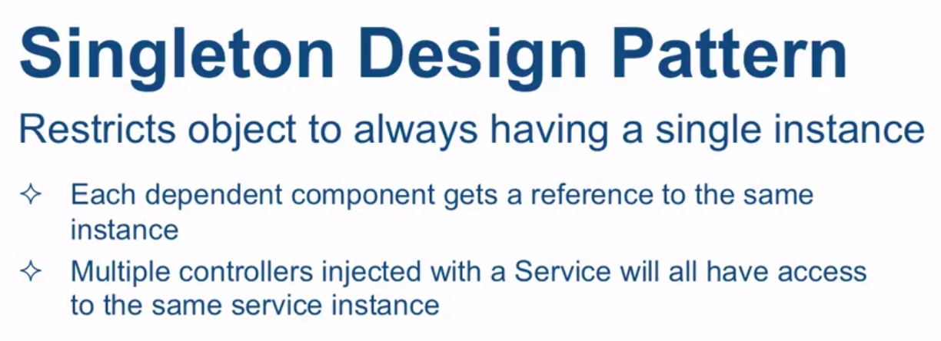
This will let as share data across the app.

Services are Lazy Instantiated
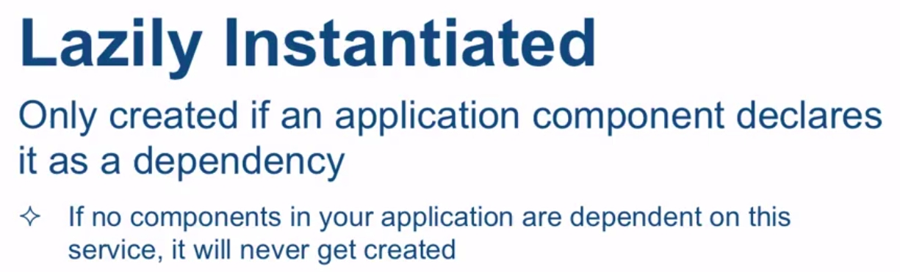

Lecture 20, part 2: custom services

The view with 2 controllers: the itemAdder and the showList controller
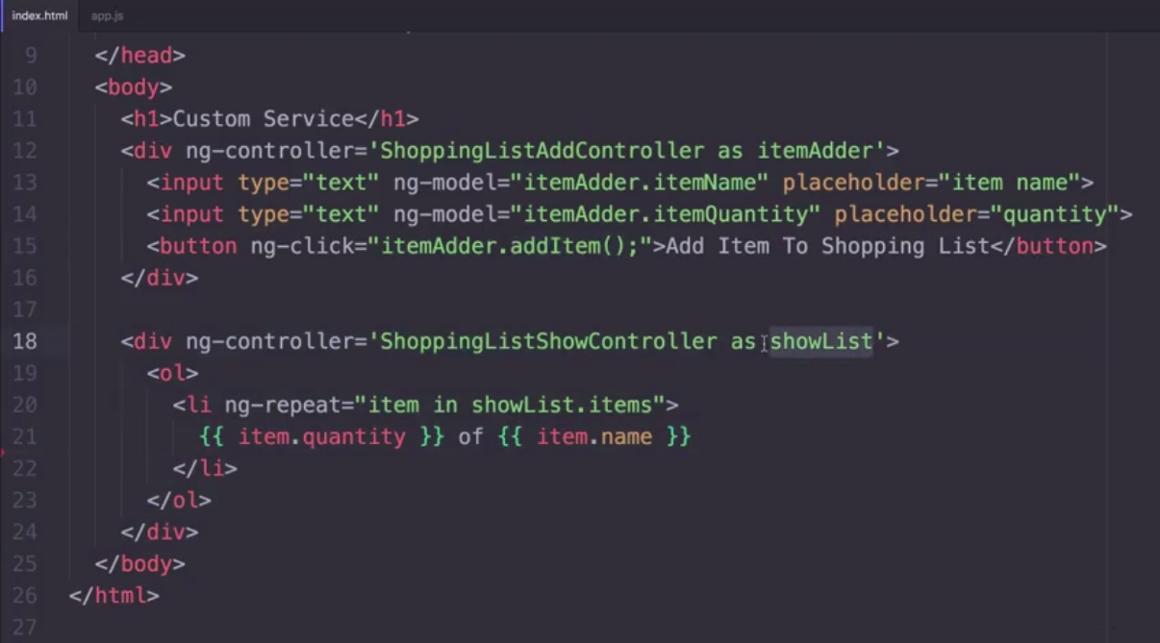

The app
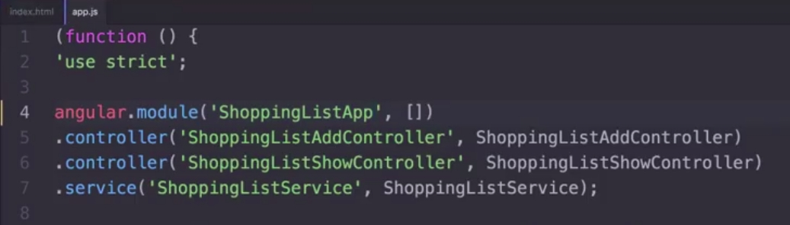
The app declares the AngularJS module, its two controllers and also the service. It also contains the code of the two controllers and the code of the service.

The ShoppingListService
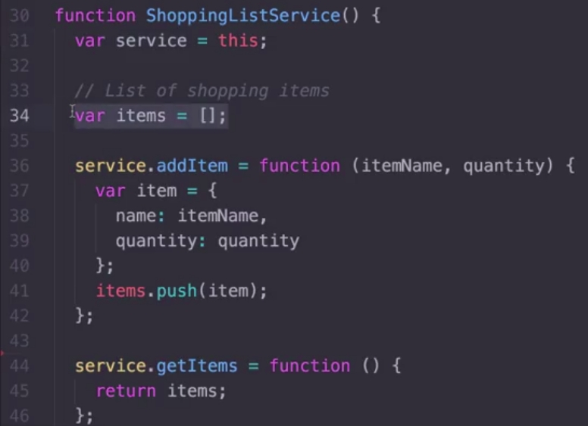

The itemAdderController
Take a look how the itemAdderController uses the ShoppingListService, and it is injected.
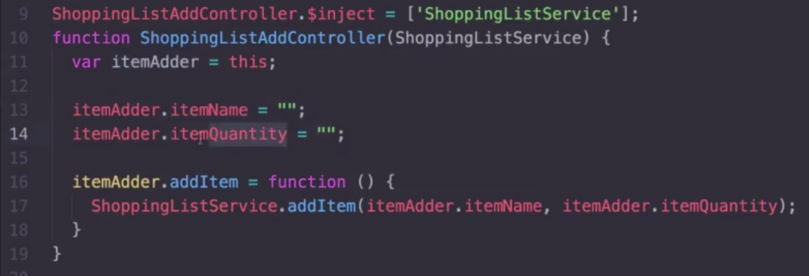

The showListController
This controller is responsible of showing the shopping list. It also injects the ShoppingListService.
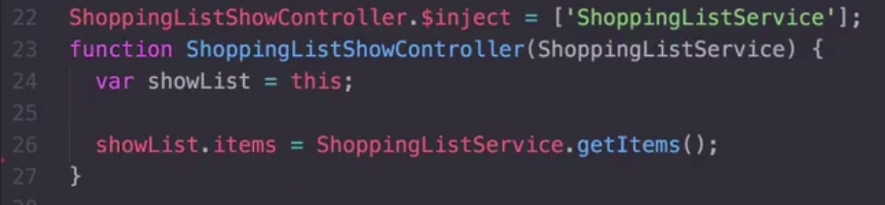

All the code working
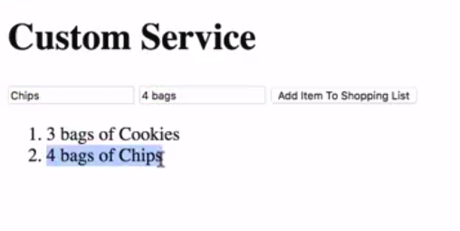
Here you can see everything working

How to code for removeItem
shoppingListService
In the service, we will add a method called removeItem, which receives the index of the item to be removed. We simply call the method splice of the arrays:
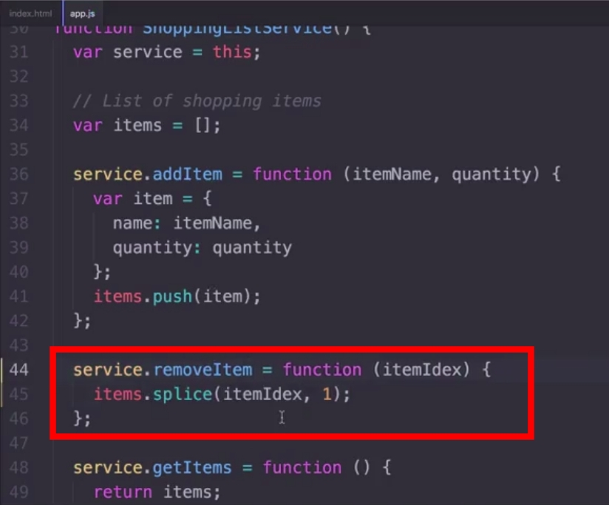

showListController
We add a new method to the showListController called removeItem which will call the method removeItem of our service:
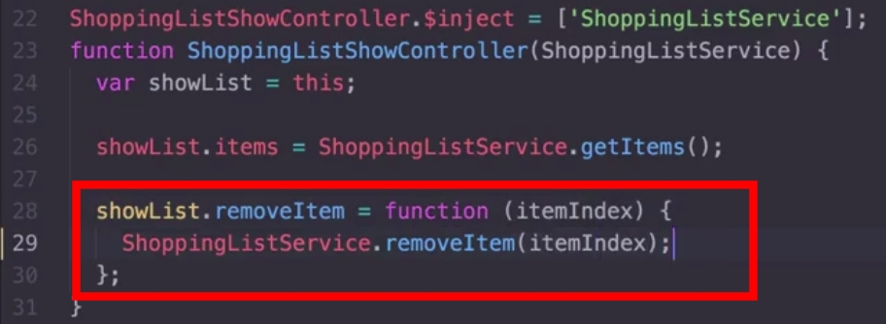
index.html
In the view, we add a button to the ng-repeat structure appended to each item, so if we press the button it will call the removeItem of the showListController. The index of the item will be the $index value of the ng-repeat structure:
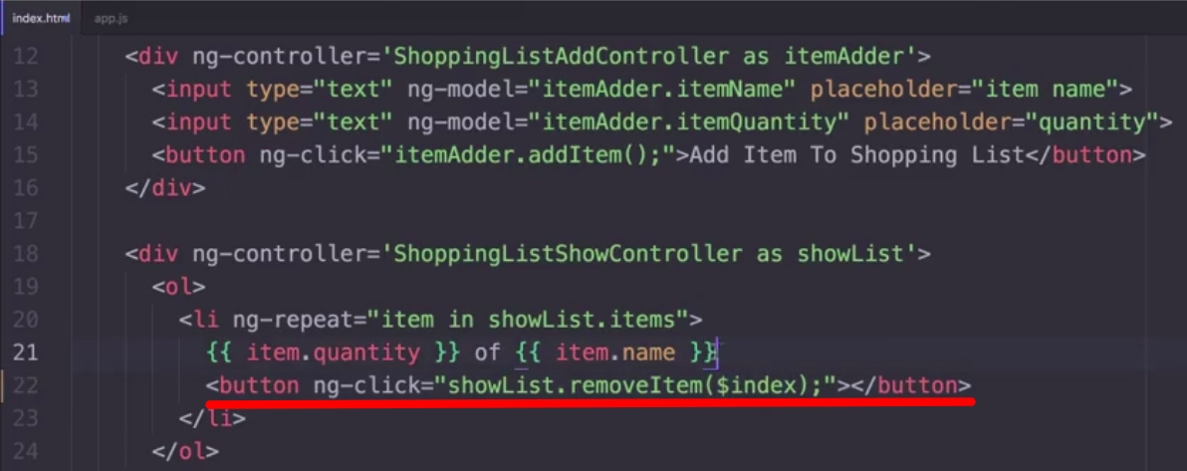
Everything working:
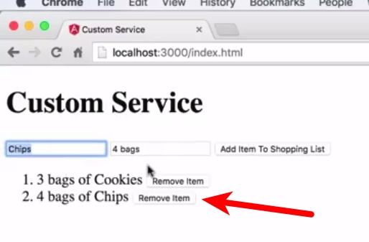
Now we do have a button for each item to remove it if we want.

Lecture 21, part 1: custom services with .factory()

Factory design pattern
This desing pattern is a central place that produces new objects or functions:
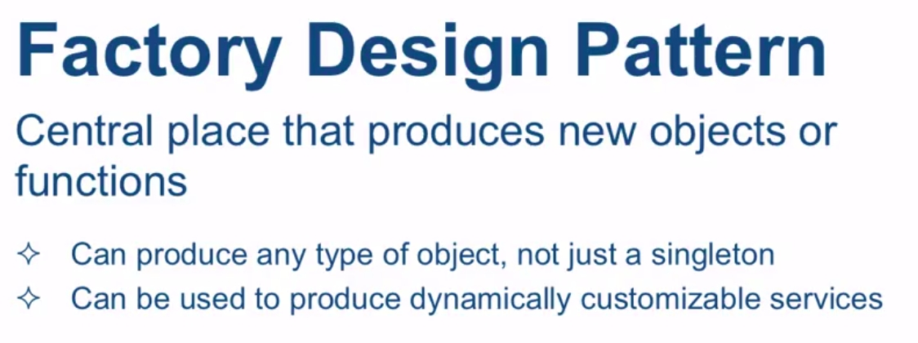

Factory is not the same that singleton
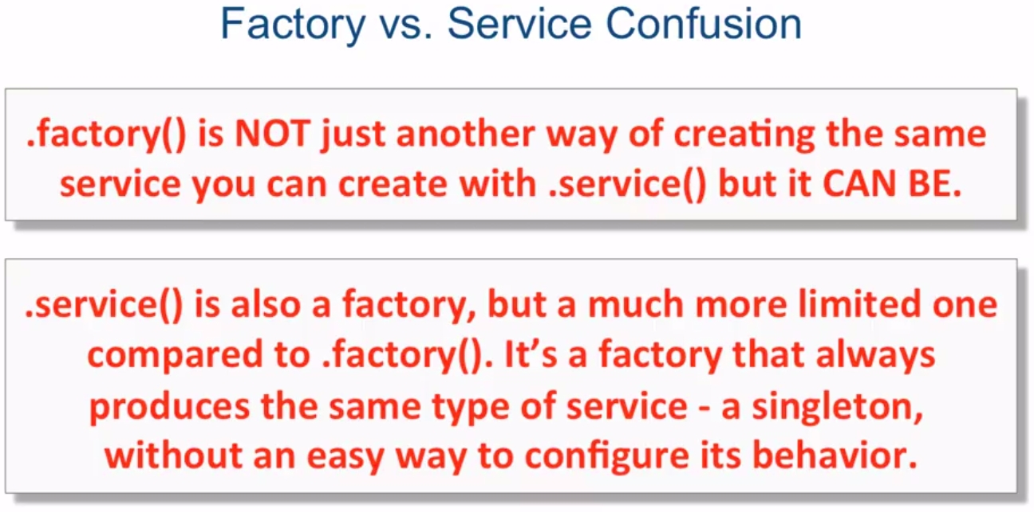

Register service factory
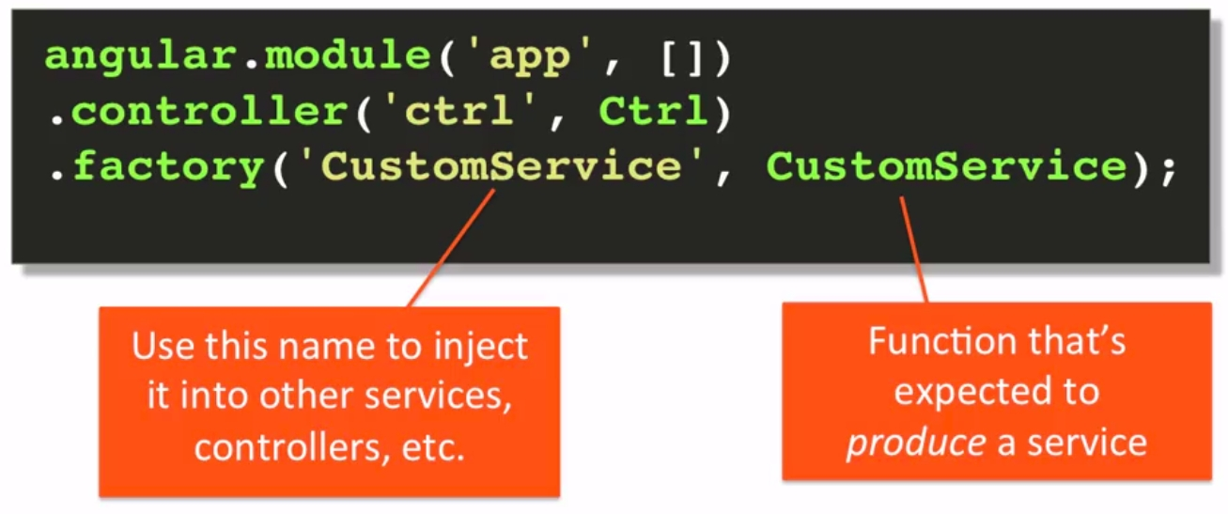

How to obtain a service from the factoryFunction
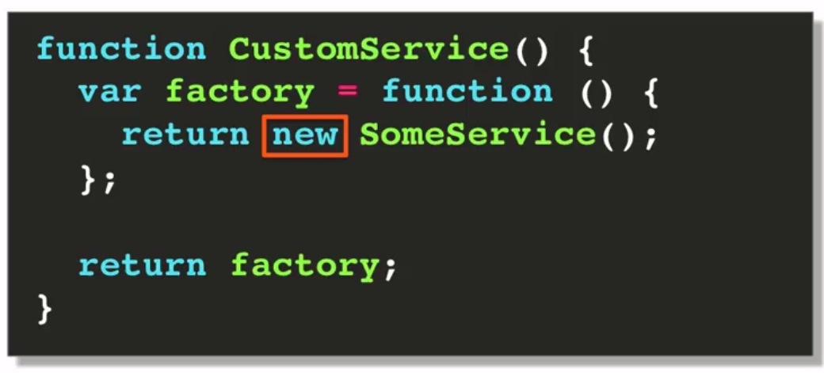

Another way to obtain a service from the factoryFunction
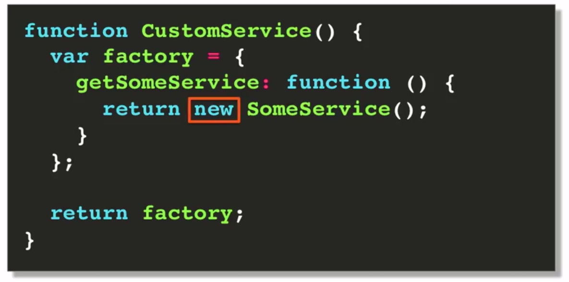

The difference between the two approaches
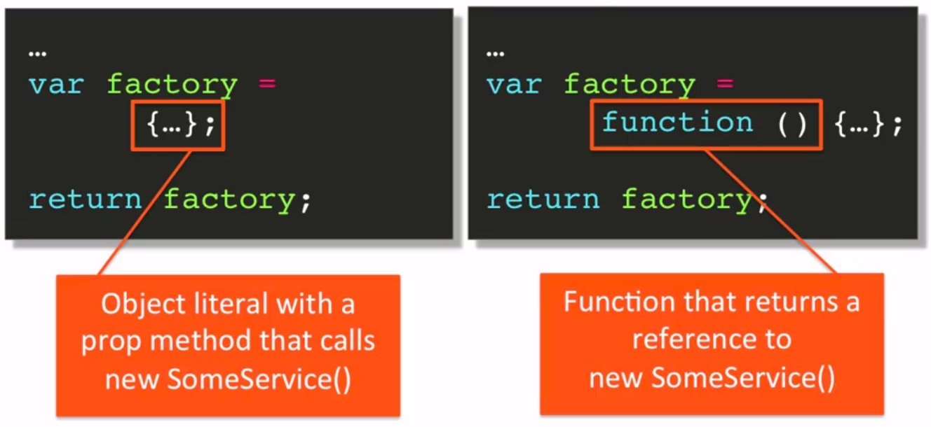
Using the factory when we implement the first approach:
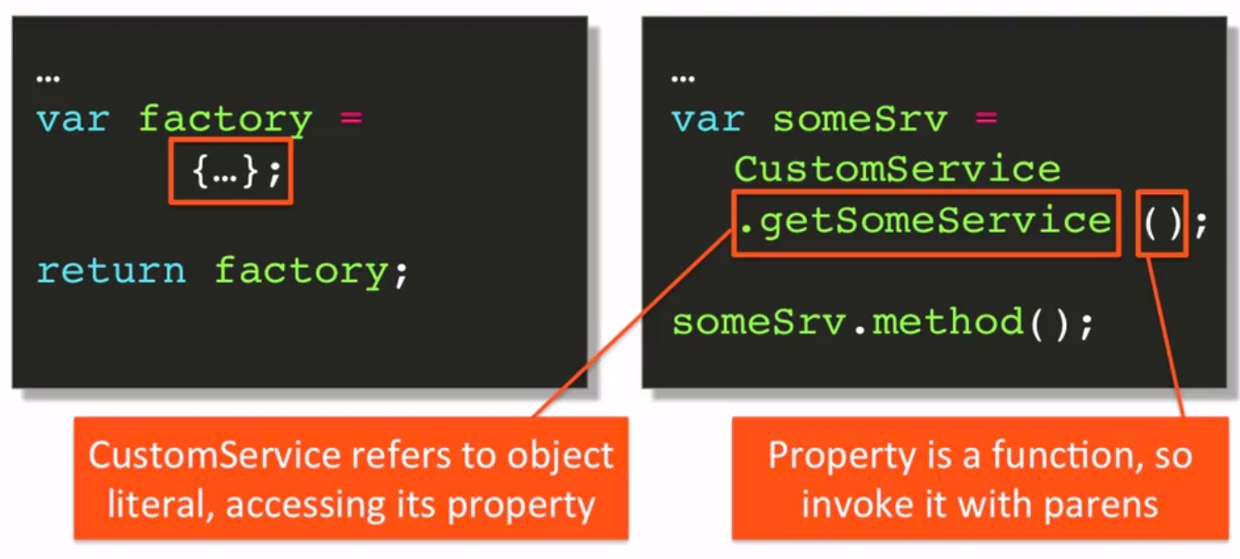

Using the factory when we implement the second approach:
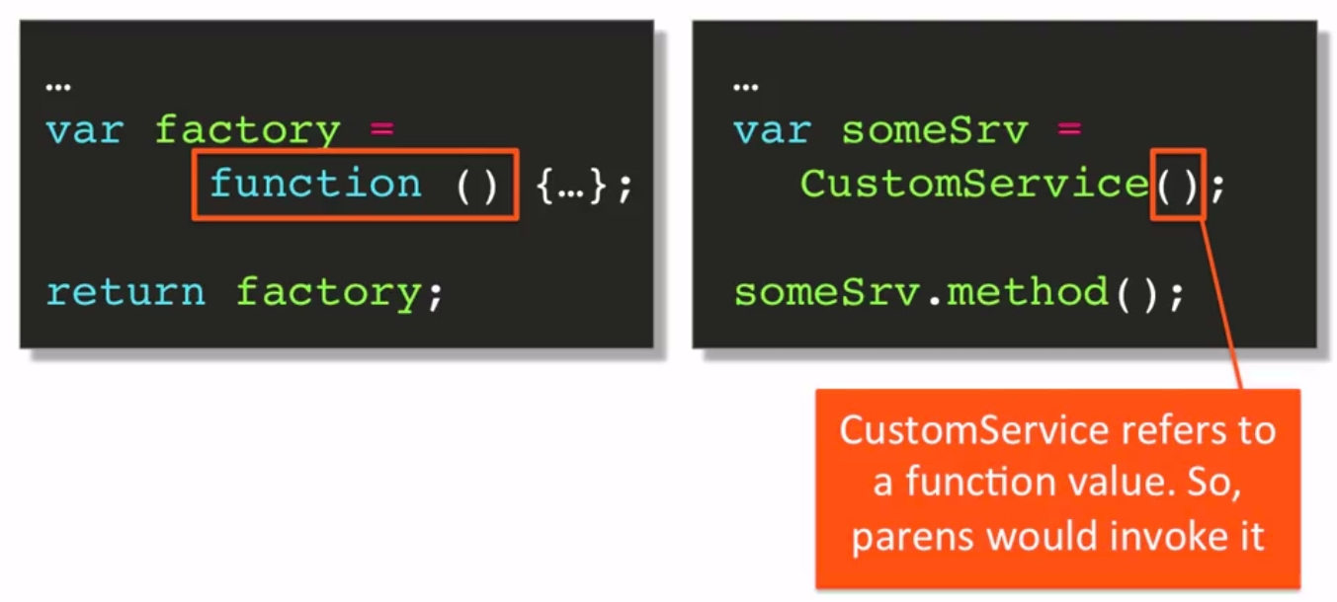

Lecture 21, part 2: custom service with .factory()
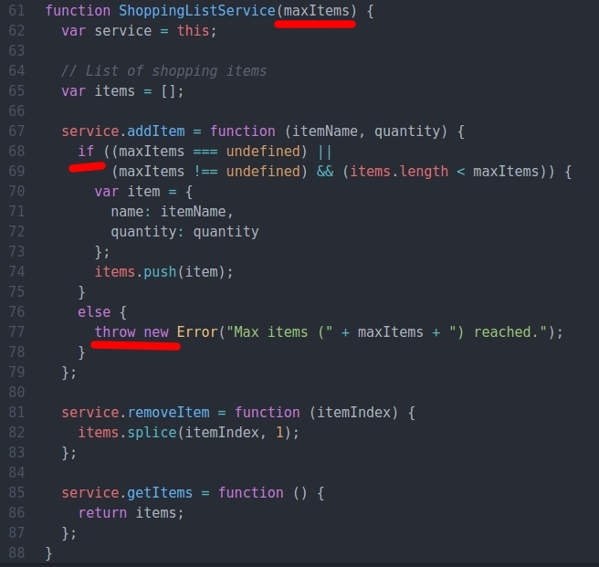
We are going to improve our shopping list example, with 2 shopping lists, the second one with a limit of 3 items in it. We can't use a singleton method because the shopping list 1 must be different from the shopping list 2.
The service
The first thing we'll do is changing the shoppingList service.
Now, it has a parameter called maxItems, which will be checked when adding a new item. If it is not defined, then the list has no maxItems, it can be added infinitum items in it. However, if it is defined a maxItem value, we can't add more items than this, and if so, an error will be thrown.
The rest of the service will be the same.
Declaring the factory
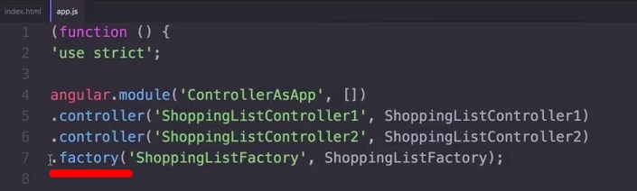
and here we have the shoppingListFactory, we have implemented it using the second approach:
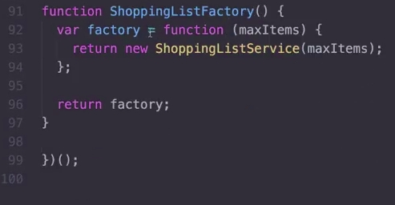

The controllers
We will have two controllers. The first one, list1, will not have maxItems defined, so we can insert infinite items in it.
Observe that we inject the shoppingListFactory in the controller.
As you see in the code, the only difference is the way we declare the shoppingList service (or factory):

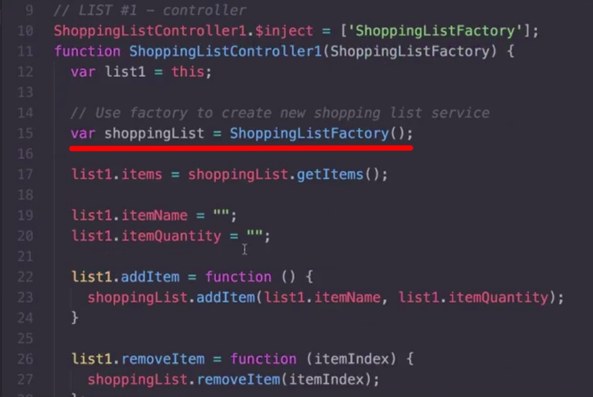

The second shoppingList will have a max of 3 items in it. Take a look at the try-catch block when we add a new item to it:
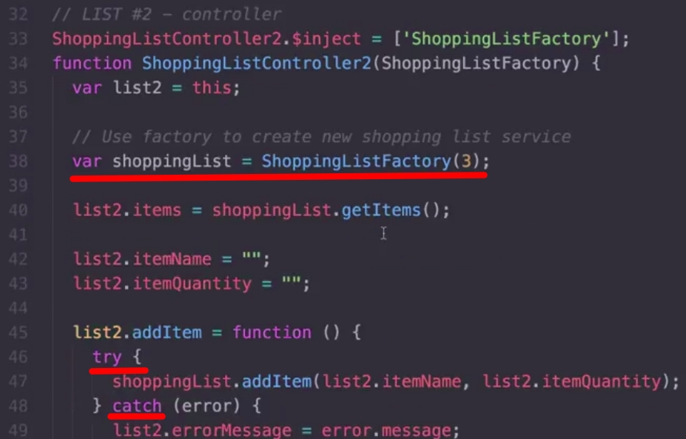

The view index.html
In the view we do have two different lists:
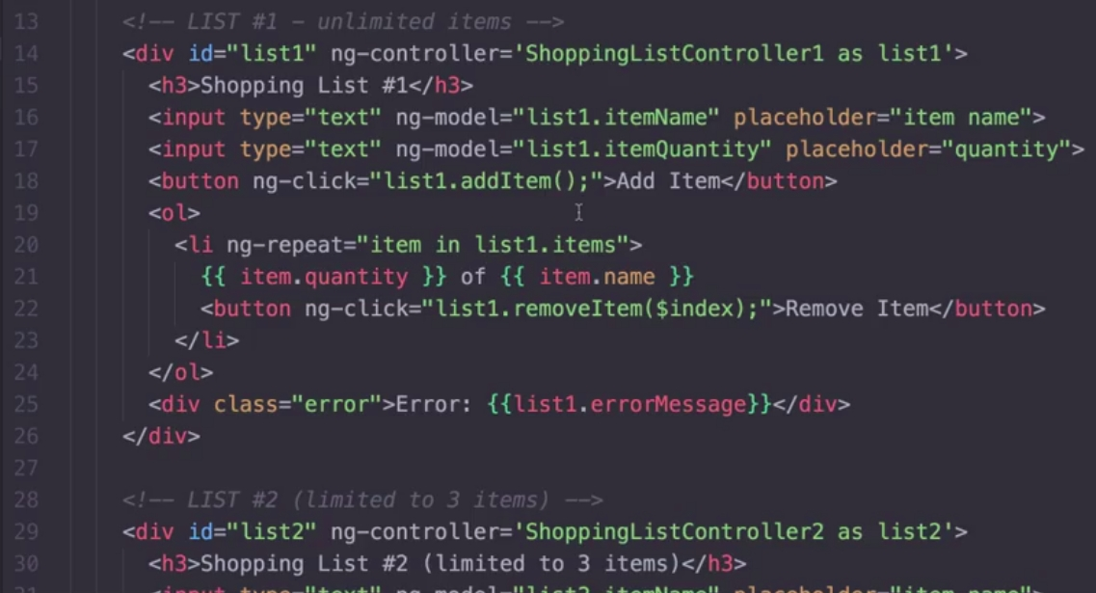

And here it is all of these working:
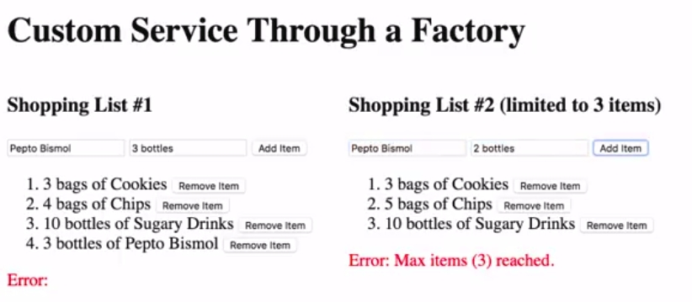

Lecture 22, part 1: custom services with .provider()

